Math 4 Name ______________________________

**5-2 Difference Quotient**  Date________

*In this Activity, you will be working towards the following learning goals:*

*I can compute and interpret average rates of change in functions*

*I can calculate and use the difference quotient for a function*

VIDEOS: “**What is Calculus?”** <http://www.youtube.com/watch?v=ismnD_QHKkQ>

**Part 1: Answer the questions based off of the videos:**

1. What is calculus?
2. What is a difference between algebra & calculus?

**Here’s some blank space!**

**Part 2:** In this portion of the lesson, you will investigate **rates of change**. Plot the following data points on the graph below. Then answer the questions.

|  |  |  |  |  |  |  |  |  |  |  |  |  |
| --- | --- | --- | --- | --- | --- | --- | --- | --- | --- | --- | --- | --- |
| Month | Jan. | Feb. | Mar. | Apr. | May | June | July | Aug. | Sept. | Oct. | Nov. | Dec. |
| Average High Temp. in ° F | 34 | 37 | 46 | 56 | 68 | 77 | 81 | 80 | 74 | 63 | 51 | 40 |

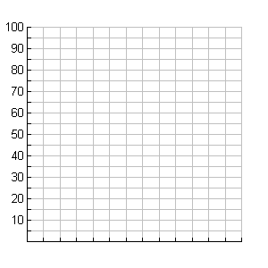

0 1 2 3 4 5 6 7 8 9 10 11 12 13

**Month**

1. To calculate *change*, what operation is used? _________________
2. What Greek letter is used to represent change? ______

Using symbols, the change in month *x*1to month *x*2 = __________ = Δ*x*

Using symbols, change in temp *y*1to temp *y*2 =___________= (or in function notation)______________= Δ*y*

1. The *average* *rate of change* is found by dividing the changes.

**Average Rate of Change** (ARoC) =  =  = ( in function notation):

4. Calculate the following (use the correct units): : :

The Geometric definition of **Average Rate of Change:**

**The slope of the line through  and .**

***If we connect the two points, we have what is called a **secant line** for the graph of the function.

 = 

5. ***Example:*** A projectile follows along a path given by the formula .

1. Complete the table of values & then graph the path of the object.

|  |  |
| --- | --- |
|  |  |
| 0 |  |
| 5 |  |
| 10 |  |
| 15 |  |
| 20 |  |
| 25 |  |
| 30 |  |
| 35 |  |
| 40 |  |
| 45 |  |
| 50 |  |
| 55 |  |
| 60 |  |

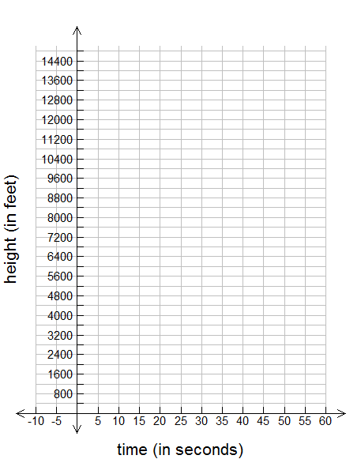

B. Use the formula from above to calculate **ARoC** over the following intervals (use the correct units):

1.)  2.) 

3.)  4.) 

1. What do your computations in part B tell you about the projectile?

D. Use a ruler to draw the secant lines going through the pairs of points. Do the direction of the lines confirm the signs of your computations in part B?

**\*\*\*Average Velocity** over an interval – the average rate of change of *directed* distance.

If average velocity > 0 🡺 The projectile is going _____________________.

If average velocity < 0 🡺 The projectile is going _____________________.

If average velocity = 0 🡺 The projectile is ­­­­­________________________________________.

**Part 3**: The concept of **ARoC** is an important one in mathematics. When many **ARoC**s have to be calculated for a particular function, *f*, it helps to have a general formula called the **Difference Quotient**. Below you will derive a general formula to help write the difference quotient for any function, *f.*

We’re going to start by representing the difference quotient geometrically/graphically. Take notes and fill in the boxes within the figure below with equivalent expressions:

*Recall:*   = 

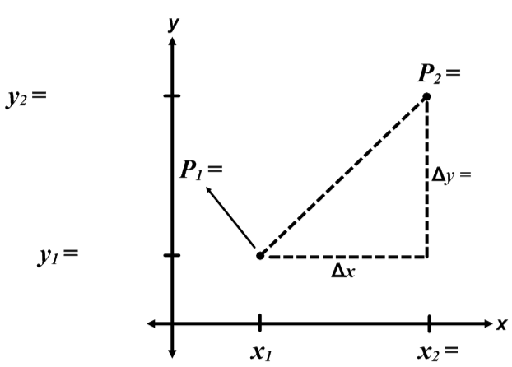

Using the coordinates you wrote above, find the average rate of change between *P*1 and *P*2 and write it in the box below. Make sure to simplify the denominator. This is the difference quotient.

**Difference quotient** =

***Example:***Refer to the projectile example, where . Find a formula for the difference quotient given the average rate of change of *h* for each interval *t* to *t + Δt.*

*\*\*\*Note: Δt is one variable!*



1. Use the results from above and *t =* 5to find the average velocity when *Δt* = . . .

Include units with your answers!

a.) *Δt* = 1 b.) *Δt* = .5 c.) *Δt* = .1 d.) *Δt* = .01

1. What is happening to the *Δt* values in part A? What value does the average velocity appear to be approaching?

Complete:  = __________________

Let . Find 

Use the result above to calculate the average velocity from 4 to 4.8 seconds.

Let . Find 