Math 4 Name_______________________________

**5-2 Learn Check** Date________

*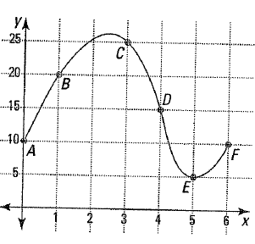In this investigation, you are being assessed on the following learning goals:*

*I can compute and interpret average rates of change in functions*

*I can calculate and use the difference quotient for a function*

**In numbers 1-4, use the graph at the right.**

1. In going from *B* to *C*, find and.

 

2. Between which two named points is ?

3. Find the average rate of change of the function from *D* to *F*.

4. Between which two named points is the average rate of change of the function zero?

5. Suppose *P* and *Q* are two points on the curve . If the *x*-coordinate of *P* is 1 and the *x*-coordinate of *Q* is 4, find the slope of the secant line .

6. Find the difference quotient, , for the function *f* defined by .

OVER🡪

7. A projectile is thrown in the air and its height (in meters) is modeled by the equation:



7a. Calculate the difference quotient

7b. Explain what the difference quotient tells you in the context of this problem.

7c. Find the average velocity of the projectile from 2 to 2.75 seconds. Include units with your answer and interpret the szign of your velocity.

8. The speed of a car (in miles per hour) traveling on the highway over time (in hours) is modeled by the equation  Find the average rate of change of the car’s speed (the car’s *acceleration*) over the interval 