Math 1 Name ______________________________

**5-4 Area and Perimeter from Coordinates** Date________

* *I can determine the area and perimeter of shapes from coordinates*

1. Graph rectangle ABCD with vertices A(4, 3), B(9, 3), C(9, 5), and D(4, 5).

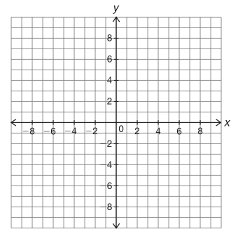

1. Find the perimeter of rectangle ABCD.
2. Find the area of rectangle ABCD.

2. Using the graph below, find the area and perimeter of rectangle RSTU. **Pay attention to the scales on the *x* and *y* axes!**

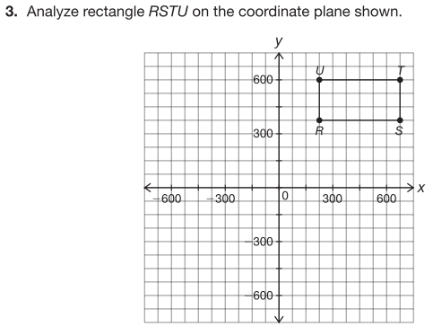

3. Find the area and perimeter of the square below.



4. Find the perimeter of a triangle with vertices at the coordinates *A*(-7, 2), *B*(-5, 13) and *C*(2, 2). Pay attention to the scale.

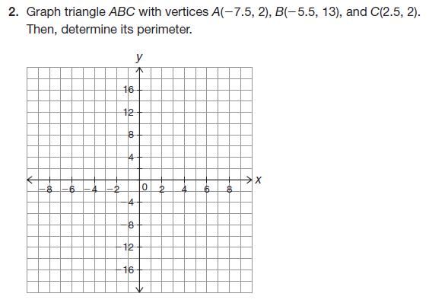

5. Find the perimeter of the figure below.

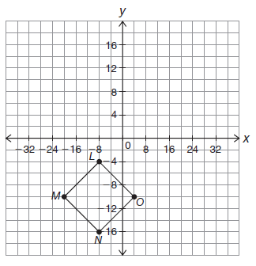

6. Given the triangle below, determine the area and perimeter.

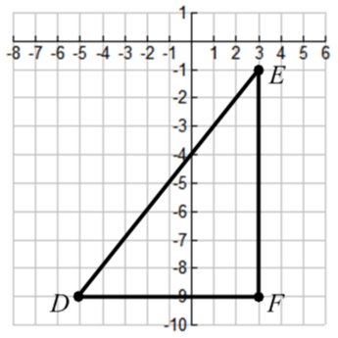

7. Graph triangle *ABC* with vertices *A*(2, 5), *B*(10, 9) and *C*(6, 1). Determine the perimeter.

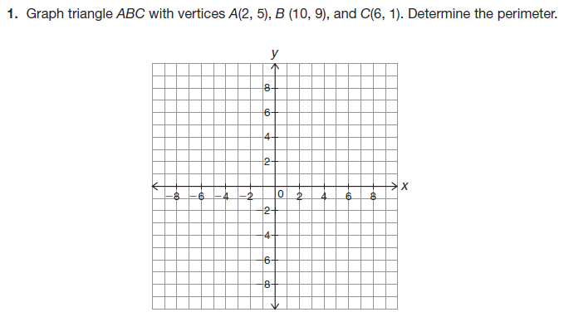

8. Graph triangle *ABC* with vertices *A*(-14, 2), *B*(-4, 2) and *C*(-12, 5). Determine the area and perimeter.

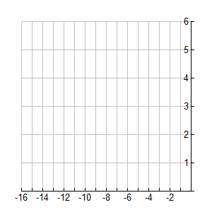

9. Find the area and perimeter of the parallelogram below.

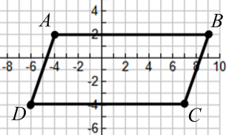

10. Graph parallelogram *ABCD* with vertices *A*(1, 1), *B*(7, -7), *C*(8, 0) and *D*(2, 8) and determine the perimeter.

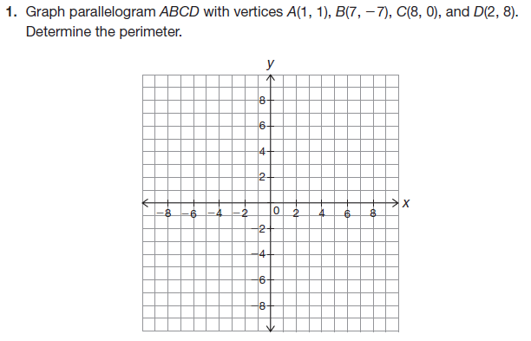

11. Find the area and perimeter of the parallelogram below. Pay attention to the scale!

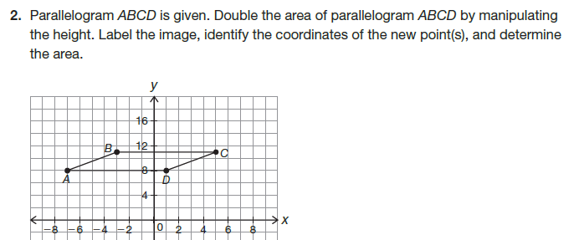

12. Find the area and perimeter of the figure below.

*Hint for area: split the figure into multiple shapes – this has already been started for you.*

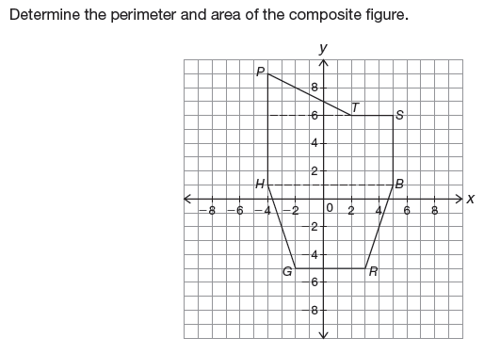

13. Find the area and perimeter of the figure below. Pay attention to the scales on the axes.

