Math 4 Name_____________________________________

**5-4 The Derivative Function** Date___________

*In this Activity, you will be working towards the following learning goals:*

*I can compute derivatives using both the definition and the power rule*

*I can use derivatives and their graphs to identify properties of functions*

**I. Definition:** Suppose that *f* is a function that has a derivative at each point *x* in the domain

of *f.* Then the function *f’*: *x →* for all *x* in the domain of *f* is called the **derivative function of *f.***

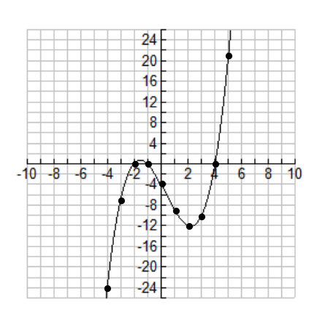**Example #1:** Consider the cubic function. Use your calculator to find the equation of the tangent lines at the given points on the graph below (all points have integer coordinates), then record the value of in the table below.

[*Directions for finding tangent lines are in the 5-3 packet*]

|  |  |
| --- | --- |
|  |  |
|  |  |
|  |  |
|  |  |
|  |  |
|  |  |
|  |  |
|  |  |
|  |  |
|  |  |
|  |  |

Plot the 10 ordered pairs on the grid & connect them with a smooth curve then answer the following questions:

1. What is the degree of *f(x)*?

1. What type of function does appear to be? What is its degree?
2. What type of function do you *think* would be? What is its degree?

Based on questions 1 – 3, what happens to the degree each time you take the derivative of a function?

**II.** **Theorem – Power Rule: The Derivative of a Quadratic Function:**

If *f(x) = ax2 + bx + c* where *a*, *b* and *c* are real numbers and *a* ≠ 0, then * =* 2*ax + b* for all real numbers *x. (*** “x” is the variable.)*



**Proof:**

**Notes about power rule:**

**Practice:** Find the derivative of the following functions:

 

 

 

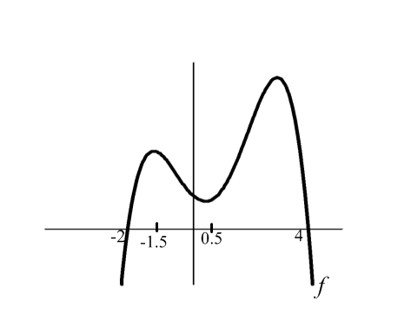

**Below is the graph of. On what intervals is ?**

**III. The Graph of the Derivative**

Below is a graph of a function *f* and its derivative.

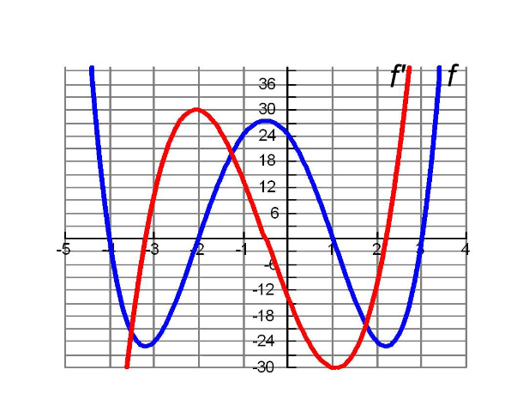

1a. On what intervals is the graph of *f* increasing?

1b. What is happening to the derivative when the graph of *f* is increasing?

2a. On what intervals is the graph of *f* decreasing?

2b. What is happening to the derivative when the graph of *f* is decreasing?

3a. Where are the local/global minimums and maximums or the graph of *f*?

3b. What is happening to the derivative when the graph of *f* is at a local/global minimum or maximum?

4. Explain why your answers to 1b, 2b, and 3b make sense.