Math 4 Name_______________________________

**5-4 Learn Check** Date________

*I can use the definition of a derivative to compute derivatives.*

*I can calculate, use and interpret the derivative for a function.*

*I can use derivatives and their graphs to identify properties of functions.*



1. Refer to the graph at the right.

1. Find the average rate of change

from A to C.

1. When is the instantaneous rate of change zero?
2. For what interval(s) of *x* is *f’(x)* is negative? e. Estimate when *x =* 4

2. Use the *definition of a derivative*, , to find the derivative of



3. Find the derivative of the following functions using the shortcut.

a.  b. 

c.  d. 

4. Refer to the graph of shown at the right.

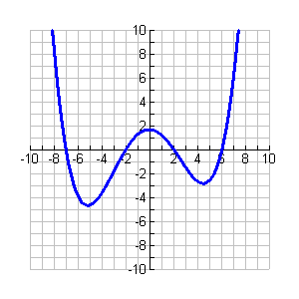

1. For what values of *x* is the derivative of *f* positive?
2. For what values of *x* is the derivative of *f* negative?
3. For what values of *x* is the derivative equal to zero?
4. Using a straightedge, draw the line that is tangent to the graph at *x* = -1.
5. Estimate the derivative of the function when *x* = -1.
6. The equation of the function graphed is: . Find 
7. Check your estimate from part **e** by substituting *x* = -1 to the derivative you found in part **f**.