Math 4 Name _________________________________

**5-4 Practice 1** Date___________

**For Numbers 1 & 2, write the expressions in the form****

1.  2. 

3. Find the following difference: 

**Use the Power Rule to find the following derivatives:**

***Notation: In addition to *,* various notations are used to denote the derivative of *f(x).*

The ones most commonly used areand . The notation of  should be thought of as the

“derivative of *y* with respect to the variable *x.*”, and it means the same as . **Write your answers without negative exponents**.

4.  

5.  

6.  

7.  

8.  

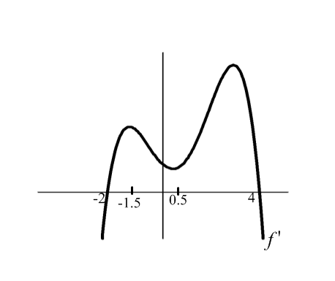9.  

10. At the right is a graph of 

a. On what interval is the graph of increasing?

Explain how you know.

b. On what interval is the graph of decreasing?

Explain how you know.

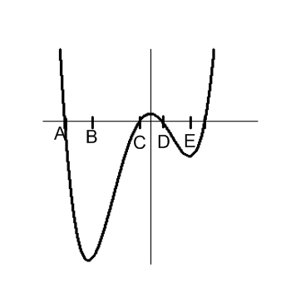11. At the right is a graph of . Give the interval(s) or point(s) where  is negative, positive and zero.

**Negative:**

**Positive:**

**Zero:**

12. A particle moves so that the distance *s* traveled in meters at time *t* seconds is given by 

a. Find the instantaneous velocity of the particle at time *t = 8*.

b. What is the initial velocity of the particle?

13. A certain flashlight is pointed directly at a wall. The area *A* in square inches of the illuminated area is , where *d* is the flashlight’s distance (in inches) from the wall.

a. Find the illuminated area at inches

b. Find the derivative of .

c. Find the instantaneous rate of change of the illuminated area when inches.

d. What does your answer to part (c) mean in the context of this problem?