Math 4 Name_________________________
5-4 Practice 2 Date________

For Numbers 1-12, differentiate each function with respect to x.
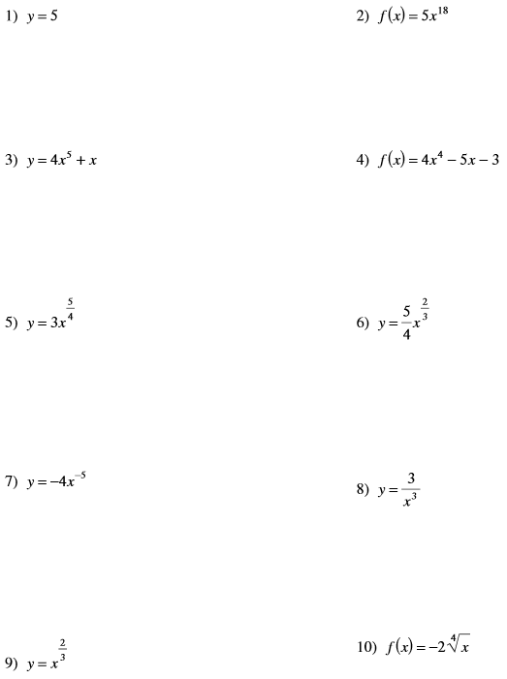

For 13-16, differentiate each function with respect to the given variable.

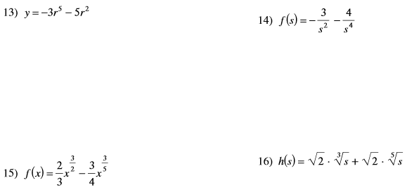

For 17 and 18, differentiate each function with respect to x.

