Math 4 Name_______________________________  
**5-4 Practice 3** Date________

1. The graph of *f(x)* is given below. Sketch a possible *f’(x).*

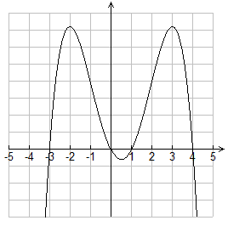

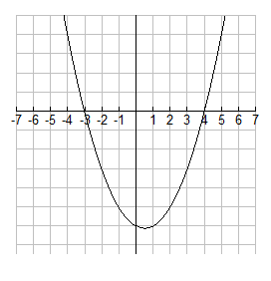2. The graph of *f’(x)* is given below. Sketch a possible *f(x)* if the point (0, 3) is on *f(x).*

3. Find the equation of the tangent line for  at *x* = 2.

4. Find the derivative of the *f*(*x*) function from #3 by using the definition of the derivative.