Math 4 Name _________________________________

**5-5 Acceleration and Deceleration**  Date___________

*In this activity you will be working towards the following learning goals:*

*I can use derivatives to find the velocity and acceleration of a moving object and solve problems involving particle motion.*

**Introduction**

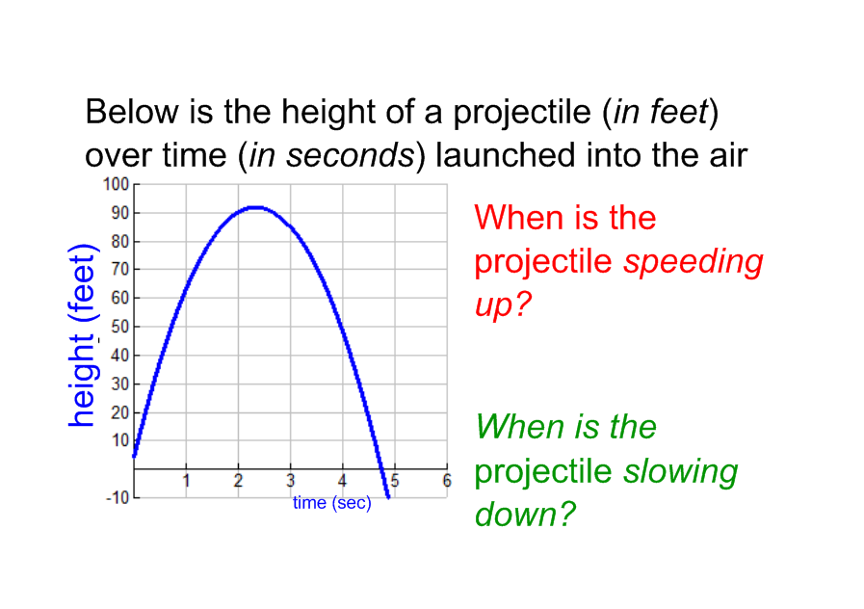

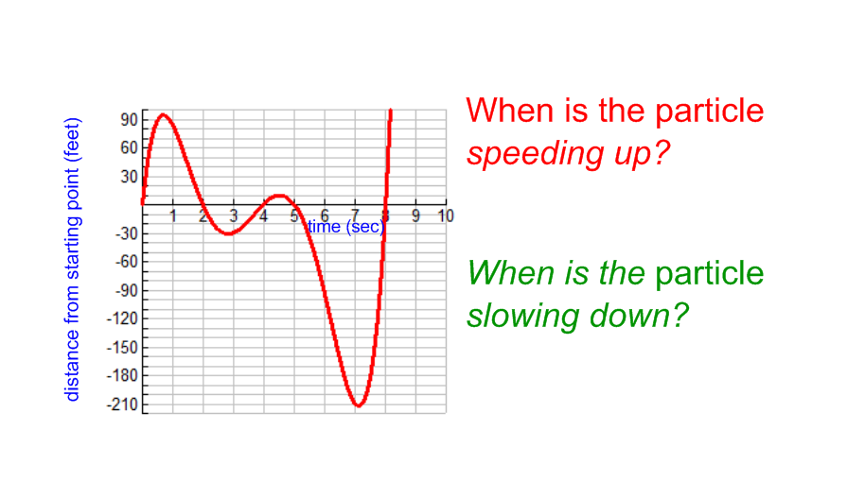

If an object is traveling at a velocity of , what does the negative sign imply?

If the object’s velocity gets “more negative”, what does that mean about the object?

If the object’s velocity gets “less negative”, what does that mean about the object?

***Applications of the Derivative Rules***

**Example #1: Projectile Motion**

The position of a projectile (in feet) after *t* seconds is given by the equation:

*h(t) = –*16*t*2 + 800*t –* 3

a. Find a formula for the instantaneous velocity of the projectile.

b. Find the instantaneous velocity of the projectile when *t =* 0, 5, 10, 15 and 20 seconds. Put your answers in the table below.

c. Find the following average rates of change in the ***velocity***: *t* = 0 to *t =* 5; *t* = 5 to *t =* 10; *t* = 15 to *t =* 20 ***Include units!!***

|  |  |
| --- | --- |
| *t* | *h*'(*t*) |
| 0 | ft/sec |
| 5 | ft/sec |
| 10 | ft/sec |
| 15 | ft/sec |
| 20 | ft/sec |

*Rate of change* in velocity from *t* = 0 to *t =* 5: ___________________

*Rate of change* in velocity from *t* = 5 to *t =* 10: ___________________

*Rate of change* in velocity from *t* = 10 to *t =* 15: ___________________

*Rate of change* in velocity from *t* = 15 to *t =* 20: ___________________

In part *c* of the previous example, you calculated the **acceleration** of the object. Complete the following statements about acceleration.

1. Acceleration is the ________________________ of a rate of change.

1. Acceleration describes how fast _________________ is changing.
2. When a car accelerates, its velocity ________________________.
3. When acceleration decreases, it is called _________________.
4. When a car decelerates, its velocity _________________.
5. The **instantaneous acceleration *a(t)*,** of a projectile at time *t* is defined as the instantaneous rate

of change of its _______________ with respect to time at time *t*, and can be calculated by taking

the derivative of the _________________ function.

In general, **position *h(t)*, velocity *v(t)*,** and **acceleration *a(t)***, are related as follows:

Velocity is the derivative of ______________________.

Acceleration is the derivative of ______________________.

∴ acceleration is the **second derivative** of ______________________.

In symbols, this looks like:

**Example #2: Velocity & Acceleration of an Object**

An object moves so that its position (in meters) at time *t* seconds is given by the function:



a. Find the function that represents the velocity of the object.

b. Find the velocity of the object when second; at *t =* 9 seconds.

**Interpret the meaning of your calculations.**

Velocity at *t = 7* is ________________. This means. . .

Velocity at *t = 9* is ________________. This means. . .

c. Find the function that represents the acceleration of the object.

d. Find the acceleration when second; at *t =* 9 seconds seconds.

**Interpret the meaning of your calculation.**

Acceleration at *t = 7* is ________________. This means. . .

Acceleration at *t = 9* is ________________. This means. . .

e. At 9 seconds, is the object speeding up or slowing down? At 7 seconds? How do you know?

f. In general, how can you tell if an object is speeding up or slowing down based on its velocity and acceleration?

**Example #3: Particle Motion**

A particle is moving along the horizontal axis in such a way that its position (in meters) at time *t* (in seconds) is given by the following function:



a. Determine a formula for the velocity of the particle.

b. Determine a formula for the acceleration of the particle.

c. For what values of *t* is the particle at rest?

d. When is the particle moving to the right? To the left? *Hint: NUMBER LINE ANALYSIS!*

e. What is the velocity of the particle when the acceleration is zero?

f. What is the position of the particle at *t =* 4 seconds?

g. When *t* = 3, what is the total distance traveled by the particle? *Refer back to your NLA analysis for help!*