Math 1 Name_________________________

**5-5 Transformations** Date________

* *I can draw a transformation when given a geometric figure and a rotation, reflection or translation.*
* *I can predict and verify the sequence of transformations that will map a figure onto another.*
* *I can define rigid motion as reflections, rotations, translations, and combinations of these, all of which preserve distance and angle measure.*
* *I can determine the coordinates for the image of a figure when a transformation rule is applied to the preimage.*
* *I can draw transformations of reflections, rotations, translations, and combinations of these using graph paper and/or geometry software.*

1. Define **translation: _________________________________________________________________**

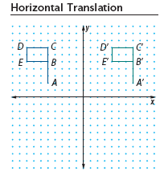Fill in the table below:

|  |  |
| --- | --- |
| Pre-Image | Translation Image |
| A( , ) | A’( , ) |
| B( , ) | B’( , ) |
| C( , ) | C’( , ) |
| D( , ) | D’( , ) |
| E( , ) | E’( , ) |

Pre-image Image

2a. Describe the *horizontal translation* of the flag as precisely as you can.

2b. The rule is (*x*, *y*) 🡪 ( , )

2c. Given the following points, what would their **image** (new position after undergoing a transformation) be under the same translation?

(0 , 0) 🡪 ( , ) (1 , -5) 🡪 ( , )

(-5 , -4) 🡪 ( , ) (*a* , *b*) 🡪 ( , )

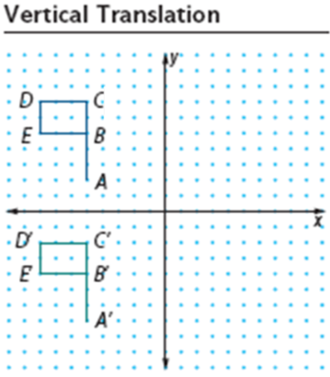

3a.

Fill in the table below:

|  |  |
| --- | --- |
| Pre-Image | Translation Image |
| A( , ) | A’( , ) |
| B( , ) | B’( , ) |
| C( , ) | C’( , ) |
| D( , ) | D’( , ) |
| E( , ) | E’( , ) |

3b. Describe the *vertical translation* of the flag as precisely as you can.

3c. The rule is (*x*, *y*) 🡪 ( , )

3d. Given the following points, what would their image be under the same translation?

(0 , 0) 🡪 ( , ) (2 , 5) 🡪 ( , )

(4.1 , -2) 🡪 ( , ) (*a* , *b*) 🡪 ( , )

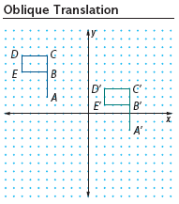4a.

Fill in the table below:

|  |  |
| --- | --- |
| Pre-Image | Translation Image |
| A( , ) | A’( , ) |
| B( , ) | B’( , ) |
| C( , ) | C’( , ) |
| D( , ) | D’( , ) |
| E( , ) | E’( , ) |

4b. Describe the *oblique translation* of the flag as precisely as you can.

4c. The rule is (*x*, *y*) 🡪 ( , )

4d. Given the following points, what would their image be under the same translation?

(0 , 0) 🡪 ( , ) (2 , 5) 🡪 ( , )

(4.1 , -2) 🡪 ( , ) (*a* , *b*) 🡪 ( , )

In general, when **translating** a pre-image *h* units horizontally and *k* units vertically, the translation

rule will be (*x, y*) 🡪 ( , )

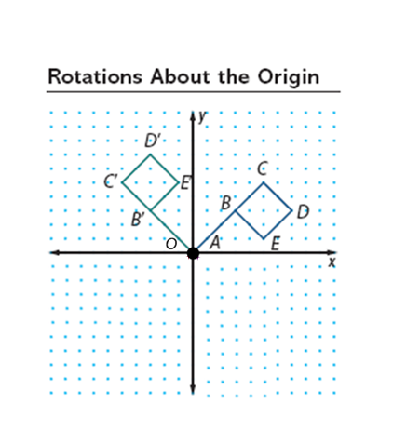

5a. Fill in the table below:

|  |  |
| --- | --- |
| Pre-Image | 90° Counterclockwise Rotation Image |
| A(0, 0) | A'( , ) |
| B(3, 3) | B'( , ) |
| C(5, 5) | C'( , ) |
| D(7, 3) | D'( , ) |
| E(5, 1) | E'( , ) |

5b. The rule for a **90° rotation** is (*x*, *y*) 🡪 ( , )

5c. Notice the angles that were formed through this rotation. For example, look at the measures of  and . How are the two angles related?

5d. The slope of the line through a pre-image point and the origin should be the ___________________

_________________________ of the slope of a line through the image point and the origin.

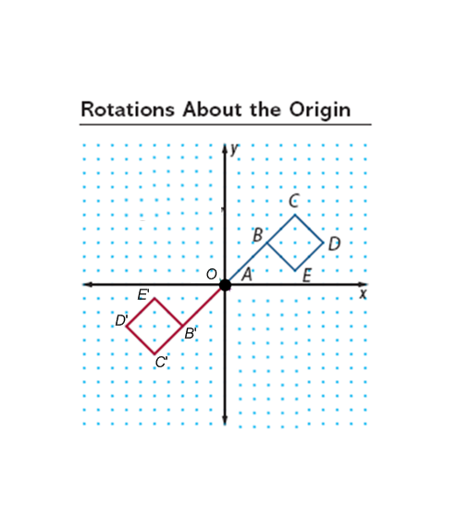6a. Fill in the table below:

|  |  |
| --- | --- |
| Pre-Image | 180° Counterclockwise Rotation Image |
| A(0, 0) | A'( , ) |
| B(3, 3) | B'( , ) |
| C(5, 5) | C'( , ) |
| D(7, 3) | D'( , ) |
| E(5, 1) | E'( , ) |

6b. The rule for a **180° rotation** is (*x*, *y*) 🡪 ( , )

6c. Notice the angles that were formed through this rotation. For example, look at the measures of  and . How are the two angles related?

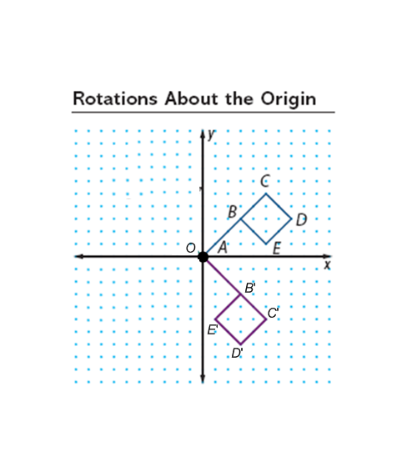

7a.

Fill in the table below:

|  |  |
| --- | --- |
| Pre-Image | 270° Counterclockwise Rotation Image |
| A(0, 0) | A'( , ) |
| B(3, 3) | B'( , ) |
| C(5, 5) | C'( , ) |
| D(7, 3) | D'( , ) |
| E(5, 1) | E'( , ) |

7b. The rule for a **270° rotation** is (*x*, *y*) 🡪 ( , )

7c. Notice the angles that were formed through this rotation. For example, look at the measures of  and . How are the two angles related?

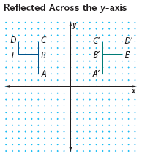8a.

Fill in the table below:

|  |  |
| --- | --- |
| Pre-Image | Reflection Image over *y-axis* |
| A(-5, 2) | A'( , ) |
| B(-5, 5) | B'( , ) |
| C(-5, 7) | C'( , ) |
| D(-8, 7) | D'( , ) |
| E(-8, 5) | E'( , ) |

8b. Describe the *y-axis reflection* of the flag as precisely as you can.

8c. The rule for a ***y*-axis reflection** is (*x, y*) 🡪 ( , )

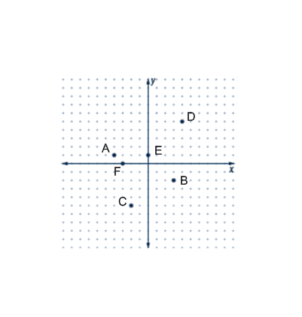9. **Reflected Across the *x –* axis**

Read #9a below then fill in the table:

|  |  |
| --- | --- |
| Pre-Image | Reflection Points over *x-axis* |
| A(-4, 1) | A'( , ) |
| B(3, -2) | B'( , ) |
| C(-2, -5) | C'( , ) |
| D(4, 5) | D'( , ) |
| E(0, 1) | E'( , ) |
| F(-3, 0) | F'( , ) |

9a. Reflect the above points *over the x-axis* on the graph. *Label* your points and write the coordinates in the table. *Draw a dotted line* connecting the pre-image points to the reflection points.

9b. What changed about the *x*-coordinates? The *y*-coordinates?

9c. Compare the x-axis to the line segments connecting your points. What does the x-axis act as?

9d. The rule for a ***x*-axis reflection** is (*x, y*) 🡪 ( , )

10. **Reflected over the line *y = x***

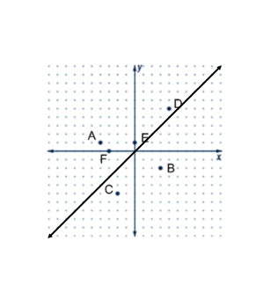 Read #10a below then fill in the table:

|  |  |
| --- | --- |
| Pre-Image | Reflection Points over *y = x* |
| A(-4, 1) | A'( , ) |
| B(3, -2) | B'( , ) |
| C(-2, -5) | C'( , ) |
| D(4, 5) | D'( , ) |
| E(0, 1) | E'( , ) |
| F(-3, 0) | F'( , ) |

10a. Reflect the above points *over the line y = x*. *Label* your points and write the coordinates in the table. *Draw a dotted line* connecting the pre-image points to the reflection points.

10b. What changed about the coordinates?

10c. Compare the line *y* = *x* to the line segments connecting your points. What does *y* = *x* act as?

10d. The rule for a **reflection over *y* = *x*** is (*x, y*) 🡪 ( , )

|  |  |
| --- | --- |
| Pre-Image | Reflection Points over *y = -x* |
| A(-4, 1) | A'( , ) |
| B(3, -2) | B'( , ) |
| C(-2, -5) | C'( , ) |
| D(4, 5) | D'( , ) |
| E(0, 1) | E'( , ) |
| F(-3, 0) | F'( , ) |

11. **Reflected over the line *y = -x***

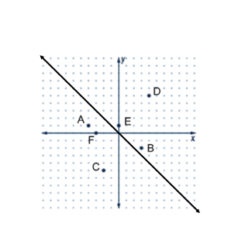 Read #11a below then fill in the table:

11a. Reflect the above points *over the line y = -x*. *Label* your points and write the coordinates in the table. *Draw a dotted line* connecting the pre-image points to the reflection points.

11b. What changed about the coordinates? *Be specific!*

11c. Compare the line *y* = -*x* to the lines connecting your points. What does *y* = -*x* act as?

11d. The rule for a **reflection over *y* = -*x*** is (*x, y*) 🡪 ( , )

12. Reflect the following figure over the line *x* = -2.

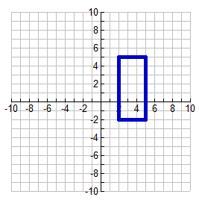

13. Reflect the following figure over the line *y =* -2.

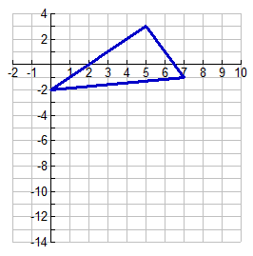

14. Triangle *ABC* has vertices at *A*(-1, 2), *B*(3, 4), and *C*(6, 0) in the coordinate plane. The triangle will be reflected over the *y*-axis and then shifted 5 units left and 2 units down. What are the new coordinates of 

