Math 4 Name _________________________________

**5-6 Learn Check** Date___________

*I can use derivatives to analyze functions.*

1. Consider the equation 

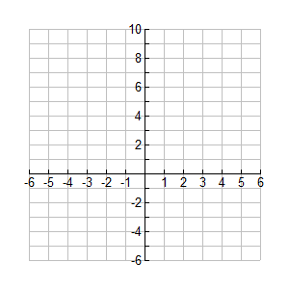1a. Determine the points where there are

maximums, minimums, or “flat spots”.

1b. Find the coordinates of the maximums,

minimums, and “flat spots”

1c. Determine the concavity of. Your answer should be intervals.

1d. Find the coordinates of the inflection point(s) of.

1e. Sketch the graph of based on the above information. Label all points you found above. DO NOT USE YOUR CALCULATOR!!

2. The graph below is of *f* '(*x*), the first derivative. *f*(*x*)

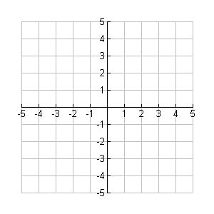 If *f*(-1) = 2,  and *f* '(*x*) is represented by the given graph, sketch *y* = *f*(*x*) as best you can. Label all inflection points.



*f* '

*x*

*x*

3.

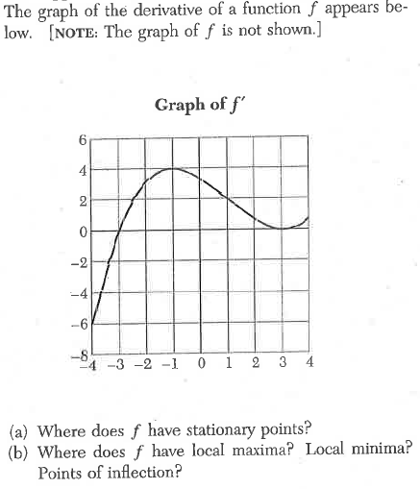

Justify your answers to both parts (a) and (b) with mathematical reasoning.