Math 1 Name ______________________________

**5-6 Proofs with Coordinate Geometry** Date________

* *I can prove or disprove a figure defined by given coordinates.*

1. Prove that the figure **is or is not** a *parallelogram*. To prove this fact, we will need to prove that

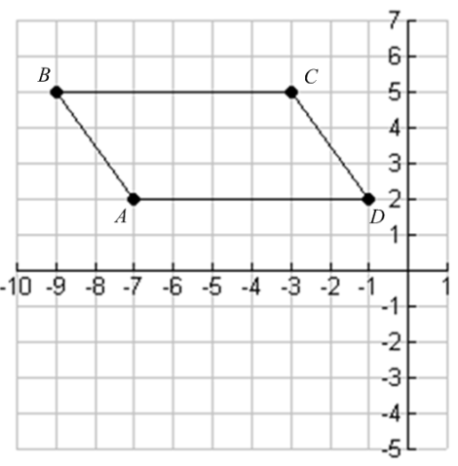

opposite sides are __________________. How do we prove it?

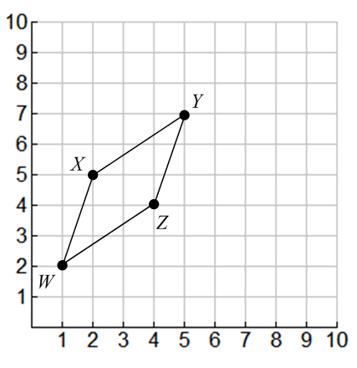2. Prove that the figure **is or is not** a *parallelogram*.

3. Prove that the figure *GHIJ*  **is or is not** a *parallelogram*. 

4. Find a fourth point that will make parallelogram *ABCD*. 

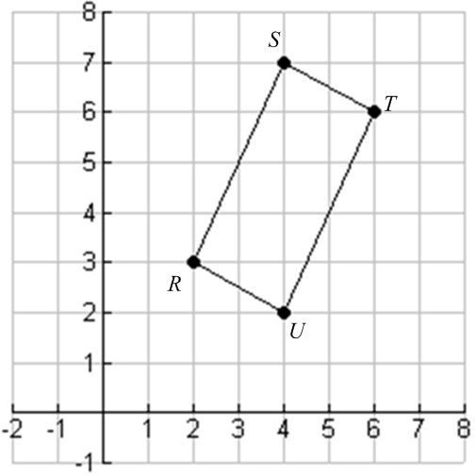5. Prove that the figure **is or is not** a *rectangle*. To prove this, we will have to use the slopes of the sides to prove that all consecutive sides are ___________________ **OR** prove that the figure is a parallelogram and then use the slopes of the sides to prove one pair of consecutive sides are__________________.

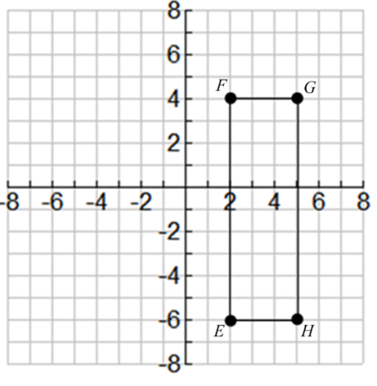6. Prove that the figure **is or is not** a *rectangle*.

7. Prove that the figure *ABCD* **is or is not** a *rectangle*. 

8. Find a point *K* that makes the figure a *rectangle*, then prove that the figure **is** a *rectangle*.

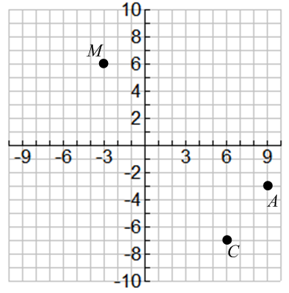

9. Prove that the figure **is or is not** a *rhombus*. To prove this, show that that all sides are ___________

**OR** prove that it is a parallelogram and one set of consecutive sides are ________________.

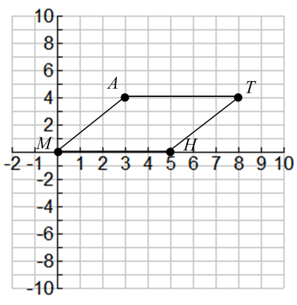

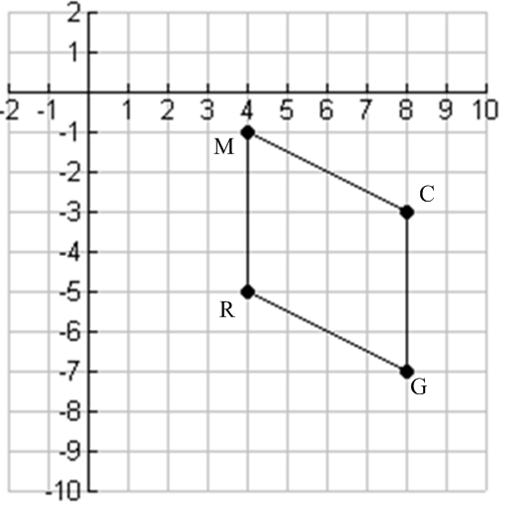10. Prove that the figure **is or is not** a *rhombus.*

11. Prove that the figure *CATS*  **is or is not** a *rhombus.* 

12. Find a point *D* that makes the figure *ABCD* a rhombus, then prove that the figure **is** a *rhombus*.

13. Prove that the figure **is or is not** a *square*. To prove this, show that all sides are

_______________________ and ***adjacent*** sides are __________________________.

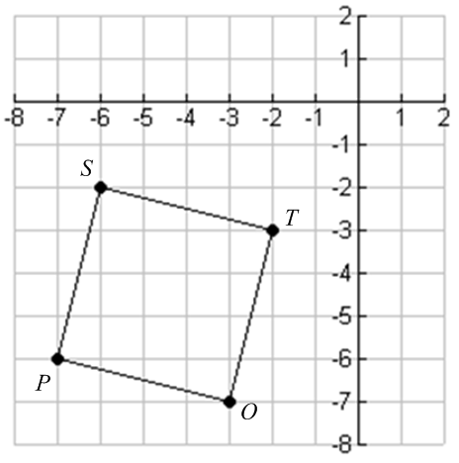

14. Prove that the figure *VEST*  **is or is not** a *square*. 

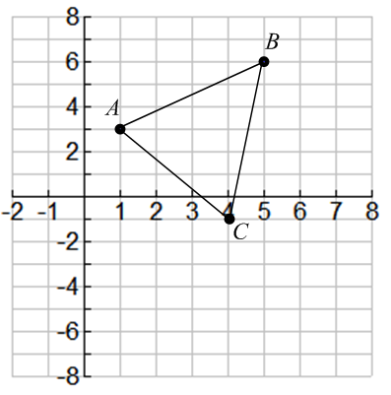15. Prove that the figure **is or is not** a *right triangle*. To prove this, show that one pair of consecutive sides are_______________________.

16. Prove that the figure *CAT*  **is or is not** a *right triangle*. 