Math 4 Name_______________________________

**5-7 Practice** Date________

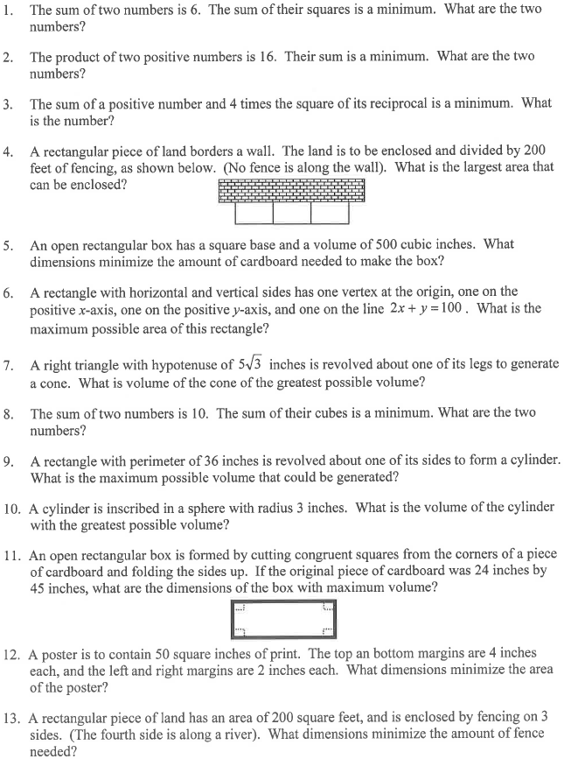**SHOW WORK ON ANOTHER SHEET OF PAPER. Problems marked with an * are challenging.**

*

*

*

*

*

*

*

*

