Math 4 Name_______________________________
5-9 Practice Date________

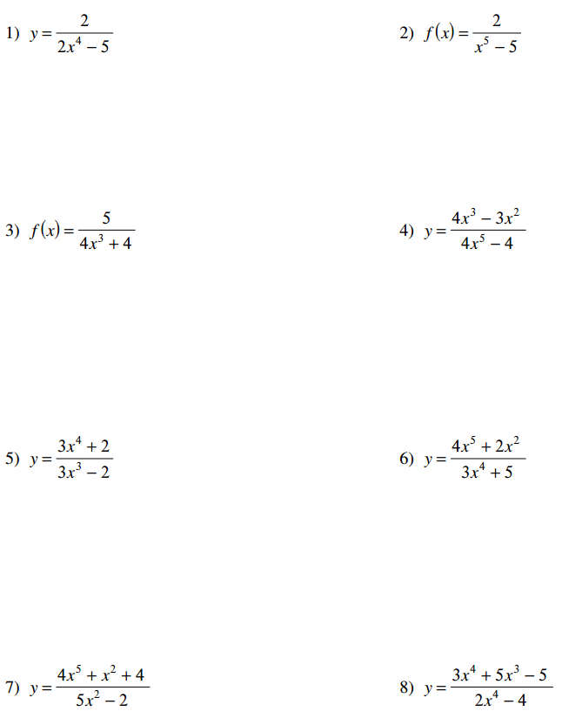
Differentiate each function with respect to x.

