Math 1 Name __________________________________

**6-1 Vocabulary Review** Date_________

Draw an example of the following vocabulary terms and then define them. *Your definition should describe your picture with enough detail so that someone else would draw the same picture as you!*

1. **PERPENDICULAR LINES** 2. **PARALLEL LINES**

Example Definition Example Definition

1. **TRANSVERSAL** 4. **LINEAR PAIR**

Example Definition Example Definition

For each given picture, write the vocabulary term that describes it, and then define it.

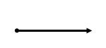

5. 6.

Vocab Word Definition Vocab Word Definition

7. 8.

Vocab Word Definition

Vocab Word Definition

Use the word bank to match the correct vocabulary term with its definition. *You will use each word once!*

1. The common endpoint in an angle.
2. Congruent, non-adjacent angles that are created by two intersecting lines.
3. A point on a line segment that divides it into two congruent segments.

**Word Bank**

Right

Equidistant

Angle Bisector

Circle

Obtuse

Vertical Angles

Intersecting Lines

Arc

Point

Midpoint

Complementary

Acute

Supplementary

Straight Angle

Vertex

1. An angle that measures between  and .
2. An angle that measures .
3. Two angles whose measures add to .
4. An angle that measures exactly .
5. Two angles whose measures add to .
6. An angle that measures less than .
7. An exact location.
8. A line, ray or line segment that divides an angle into two congruent parts.
9. A part of the circumference of a circle.
10. The set of all points equidistant from a center point.
11. Two lines that cross at a single point.
12. When two points on a line segment are the same length apart from its midpoint.

Given the diagram below, answer the following questions:

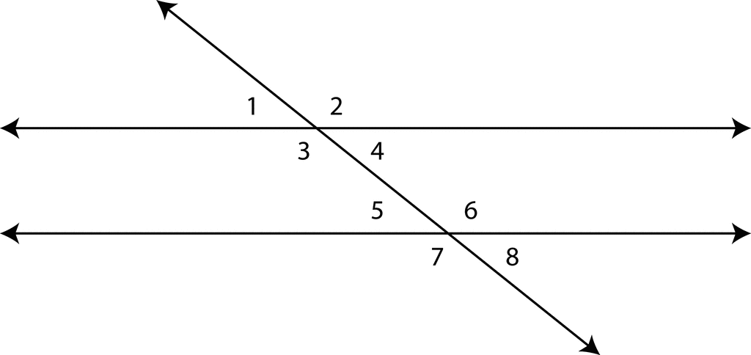

1. **Corresponding angles** are on the ( same / opposite ) side of the transversal, in corresponding positions.

Are they congruent? ____________

Name a pair of corresponding angles: _______________________

1. **Interior angles** are ( inside / outside ) the parallel lines.

Name an interior angle: _________________

1. **Exterior angles are** ( inside / outside ) the parallel lines.

Name an exterior angle: _________________

1. **Alternate interior angles** are ( inside / outside ) the parallel lines, and on ( opposite / same ) sides of the transversal.

Are they congruent? ____________

Name a pair of alternate interior angles: _______________________

1. **Alternate exterior angles** are ( inside / outside ) the parallel lines, and on ( opposite / same ) sides of the transversal.

Are they congruent? ____________

Name a pair of alternate exterior angles: _______________________

1. **Same-side exterior angles** are ( inside / outside ) the parallel lines, and on ( opposite / same ) sides of the transversal.

Name a pair of same-side exterior angles: _______________________