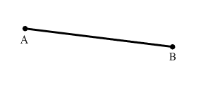Math 1 Name__________________________________

**6-3 Vocabulary Applications 1** Date_________

1. Give another name for. _______

B

B

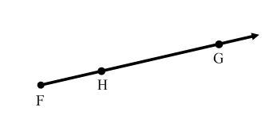__________________________________________________________________________________________________

2. Give another name for. _______

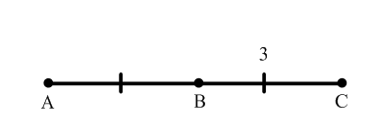__________________________________________________________________________________________________

3. What is the length of ? _______

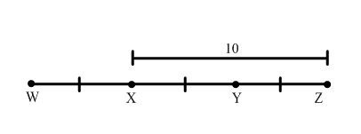__________________________________________________________________________________________________

4. What is the length of ? _______

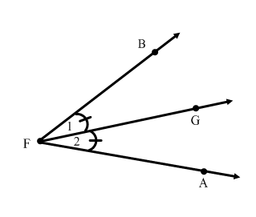__________________________________________________________________________________________________

5. Give another name for angle 1. _______

6. Give another name for angle 2. _______

7. is a _____________ of .

8. If the measure of angle 1 is 37o, then

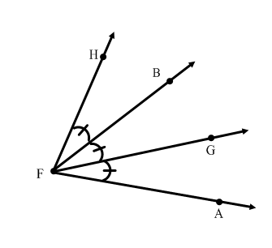 what is the measure of? _______ __________________________________________________________________________________________________

9. If the , then what is the ? _______

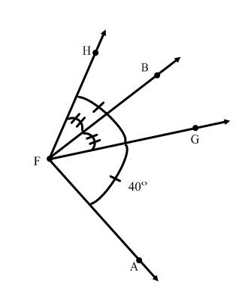__________________________________________________________________________________________________

10. What is the ? _______

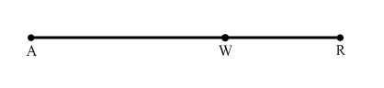11. Give another name for . _______

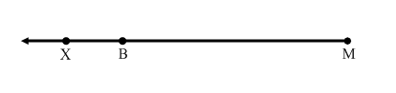__________________________________________________________________________________________________

12. Give another name for . _______

__________________________________________________________________________________________________

**For numbers 13-15, sketch the given situation.**

13. Point D is between points R and S on line *m*.

14. 

15.  intersects line *n* at point Q.

__________________________________________________________________________________________________

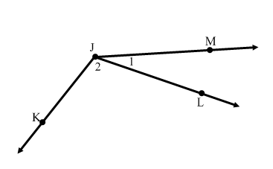**For numbers 16-18, give another name for each angle.**

16.  _______

17.  _______

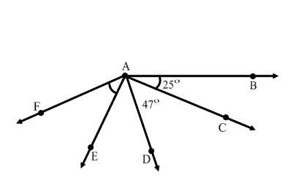18.  _______

__________________________________________________________________________________________________

**For numbers 19-24, use the diagram to the right.**

19. Find . _______ 20. Find . _______

21. If , find . _______

22. If , find . _______

23. If , find . _______

24. If , find . _______

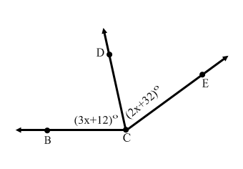__________________________________________________________________________________________________

25. In the diagram to the right, .

a. Find the value of *x*. _______

b. Find . _______

c. Find . _______

d. Does  bisect ? _______

__________________________________________________________________________________________________

26. a. is a segment with midpoint M. and ,

solve for *x*. _______

b. What is the length of ? _______