Math 1 Name ________________________

**6-3 Vocabulary Applications 2** Date________

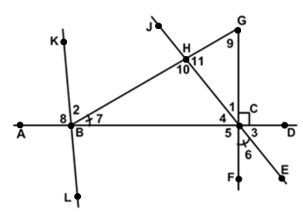

**Use the picture to the right to answer questions 1-10.**

1. Name two pairs of vertical angles.
2. Name two linear pairs.
3. Name two pairs of supplementary angles.
4. Name two pairs of congruent angles.
5. Name a pair of complementary angles.
6. Give two other names for ∠2.
7. Name a pair of perpendicular line segments.
8. Name an obtuse angle, an acute angle and a right angle.
9. Assuming *m*∠1 = 38o and *m*∠2 = 58o, find the measure of angles 2-11.

∠3________ ∠4________ ∠5________

∠6________ ∠7________ ∠8________

∠9________ ∠10________ ∠11________

**Sketch drawings of the following:**

1. *q* || *p* 11. ∠NBC $≅$ ∠ABC and $\vec{BG}$ bisects ∠NBA

12. 13.

14. Lines *m* and *n* are parallel with transversal *t*.

Use the picture at the right to answer the following questions:

1. and 

Solve for *x*.

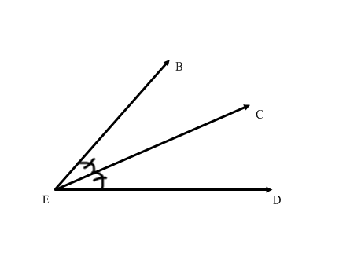

1. *m*∠BEC =
2. *m*∠CED =
3. *m*∠BED =

Use the picture to the right to answer the following questions:



1. 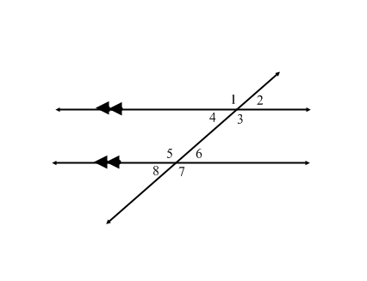If and

Solve for *x*.

1. What is the *m*∠1?
2. What is *m*∠3?
3. What vocabulary word describes ∠1 and ∠3?
4. What vocabulary word describes ∠1 and ∠2?
5. What is *m*∠2?
6. If  and 

Solve for *x*.

1. What is the *m*∠1?
2. What is *m*∠8?
3. What vocabulary word describes ∠1 and ∠8?
4. What vocabulary word describes ∠8 and ∠7?
5. What is *m*∠7?

Use the picture at the right to answer the following questions:

1. 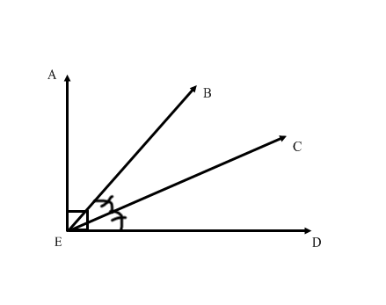What vocabulary word describes $\vec{EC}$?
2. and 

Solve for *x*.

1. *m*∠AEB =
2. *m*∠BEC =
3. *m*∠CED =
4. *m*∠AEC =
5. *m*∠BED =
6. Draw $\vec{XY}$.
7. Draw $\vec{YX}$
8. Draw $\overline{PU}$
9. Give another name for $\overline{PU}$.
10. Draw $\overset{⃡}{TM}$
11. 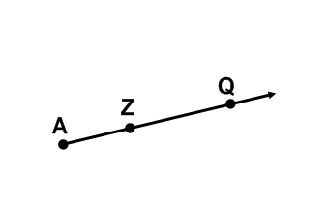Give another name for $\overset{⃡}{TM}$.
12. What’s another name for $\vec{AZ}?$

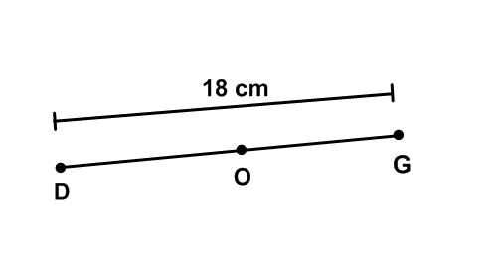

1. Assuming O is the midpoint of DG,

what is the length of DO?

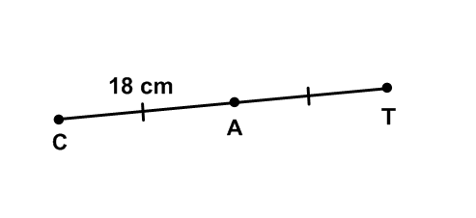

1. What is the length of CT?

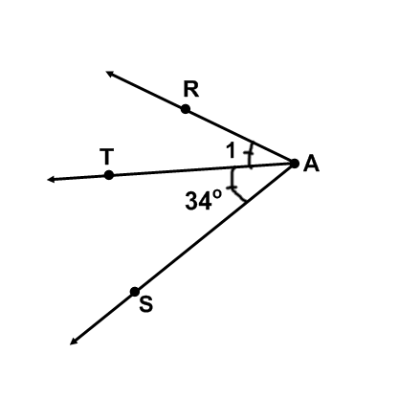

1. Give another name for angle 1 using three points.
2. What is $\vec{AT}$ called?
3. What is the measure of $∠RAS$?
4. Draw: $\overline{YZ}$ intersects line *q* at point *Z*.
5. 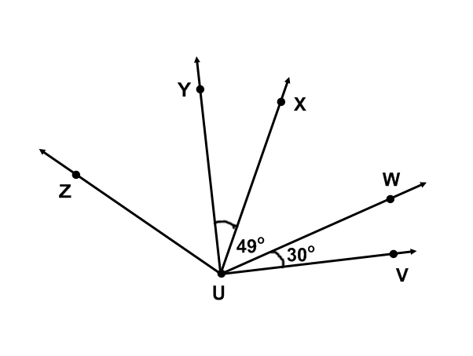 What is the measure of $∠XUY$?
6. What is the measure of $∠VUX$?
7. If $∠WUX≅∠YUZ$, find the measure of $∠VUZ$.
8. Find the measure of $∠YUV$.
9. If m is 52o, what is the measure of $∠ZUW$?
10. 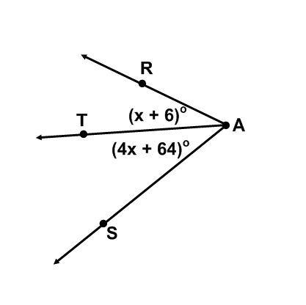Find *x* using the diagram to the right if m = 80o.
11. Find the measure of .