Math 1 Name_______________________________  
**6-4 – 6-5 Triangle Properties and Parallel Lines Review 2** Date________

1. The three interior angels of any triangle sum to ________ degrees.

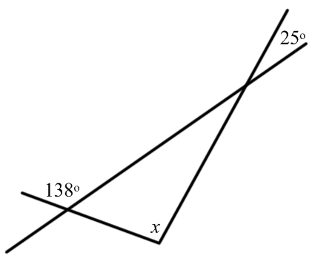

**Find the value of *x* in each of the figures below.**

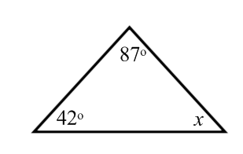

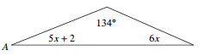2. 3. 4.

5. The measure of an exterior angle of a triangle is equal to the _______ of the measures of the

__________________________________________.

**Find the measure of angle marked with a question mark in each figure below.**

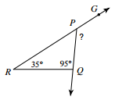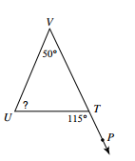

6. 7.

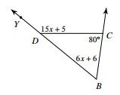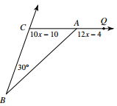7. Find the measure of  8. Find the measure of 

9. The sum of any two sides of a triangle must be ______________ than the length of the third side.

**Can a triangle be created with the following side lengths?**

10. 3, 7, 8 11. 9, 4, 5 12. 15, 28, 46

**Two sides of a triangle are given. Find the range of possible lengths for the third side.**

13. 2 & 10 14. 12 & 5 15. 21 & 57

16. List two properties of isosceles triangles below.

**Solve for *x*** **(and *y* if it exists) in the problems below.**

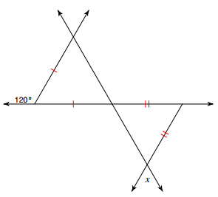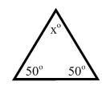

17. 18.

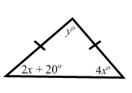

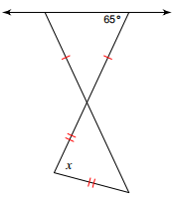19. 20.

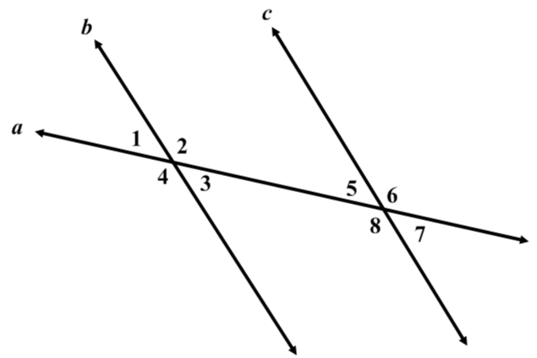21. Show **two** different ways to prove the following:





22. Show **two** different ways to prove the following:

