Math 1 Name _________________________________  
**6-4 Triangle Properties Practice** Date_________

* *I can use theorems, postulates, or definitions to solve problems involving triangles.*

**1. Triangle Sum Theorem: ________________________________________________________________**

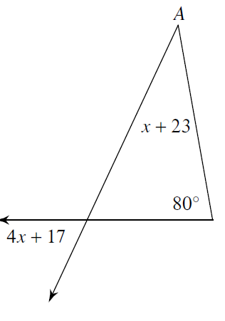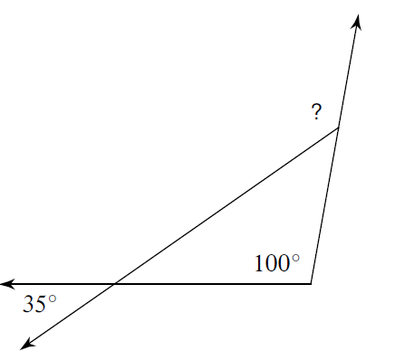a. Find the measure of the indicated angle. b. Find the measure of angle A

**2. Exterior Angle Theorem: __________________________________________________________________**

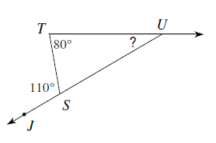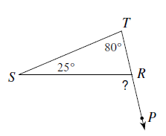a. Find the measure of the indicated angle. b. Find the measure of the indicated angle.

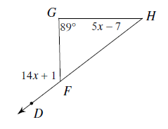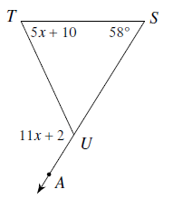c. Solve for *x*. d. Find 

**3. Triangle Inequality Theorem: ___________________________________________________________**

Could a triangle be formed with the following side lengths?

a. 7, 5, 4 b. 9, 6, 5 c. 3, 6, 2

Two sides of a triangle are given. Find the range of possible measures for the third side.

d, 9, 5, e. 5, 8,

**4. Isosceles Triangle Properties: _______________________________________________________________**

Find the value of *x*.

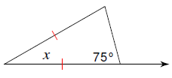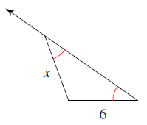a. b.

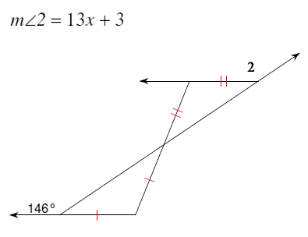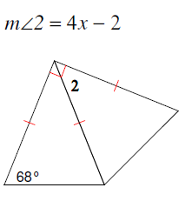

c. d.