Math 1 Name ___________________________  
**6-4 Triangle Properties Notes** Date________

* *I can use theorems, postulates, or definitions to solve problems involving triangles.*

**Triangle Sum Theorem:**

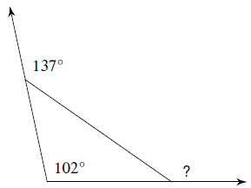

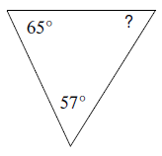Find the measure of each angle indicated:

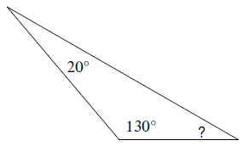1. 2. 3.

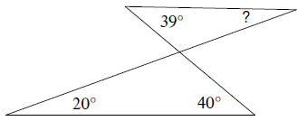

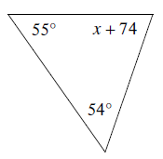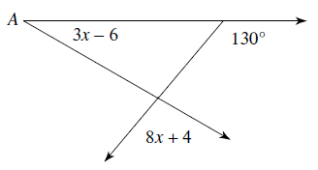4. 5. Solve for  6. Solve for *x*.

**Exterior Angle Theorem:**

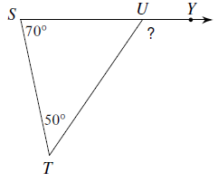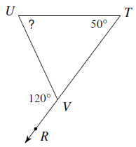Find the measure of each angle indicated:

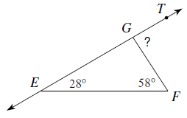7. 8. 9.

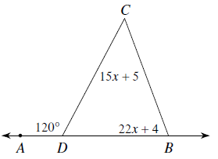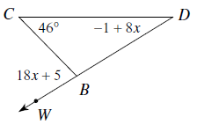10. Find the measure of  11. Find the measure of  12. Find the measure of 

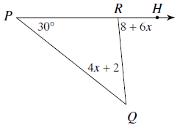

**Triangle Inequality Theorem:**

Could a triangle be formed with the following side lengths?

13. 3, 5, 7 14. 20, 48, 25 15. 35, 65, 35

16. Two sides of a triangle are given. Find the range of possible measures for the third side.

a. 12 and 17 b. 23 and 35

**Isosceles Triangle Properties:**

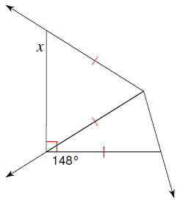

Solve for *x* in the following.

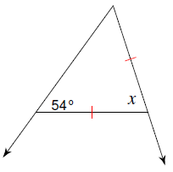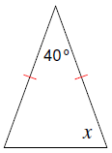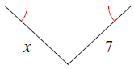17. 18. 19. 20.

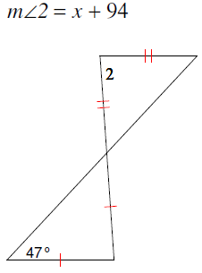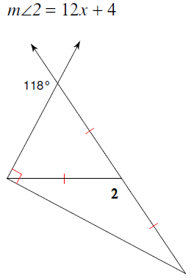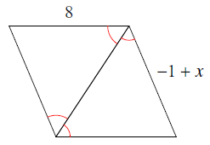21. 22. 23.