Math 1 Name_________________________

**6-5 Introduction to Proofs** Date________

* *I can order statements based on logic when constructing my proof.*
* *I can use theorems, postulates, or definitions to prove theorems about lines and angles.*

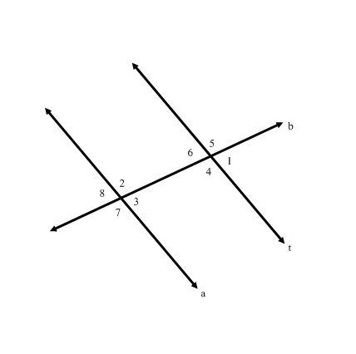Use the diagram to the right to answer Questions 1 & 2. Assume 

1. What is the relationship between the angle measures of 
2. Explain how you know the answer to #1 is correct. Make sure you use some of the vocabulary words you’ve learned this quarter.

Use the diagram to the right to answer Questions 3 & 4. Assume 

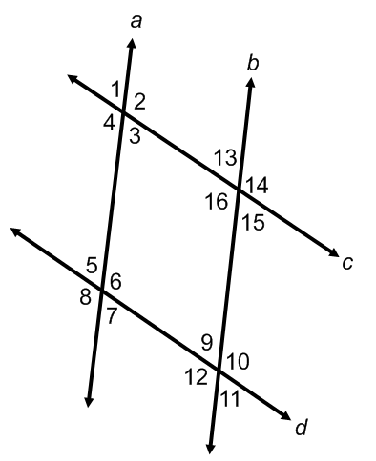

1. What is the relationship between the angle measures of 
2. Explain how you know the answer to #1 is correct. Make sure you use some of the vocabulary words you’ve learned this quarter.