Math 1 Name_______________________________

**6-5 Parallel Lines Proofs Part 2** Date________

* *I can order statements based on logic when constructing my proof.*
* *I can use theorems, postulates, or definitions to prove theorems about lines and angles.* 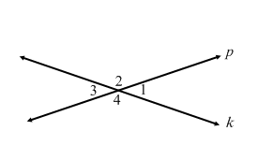

1. Complete the following proof:

Given: Lines *k* and *p* intersect at a given point.

Prove: 

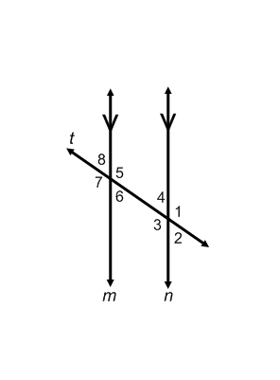

2. Given: Line *m* is parallel to line *n* with transversal *t*.

Prove: 

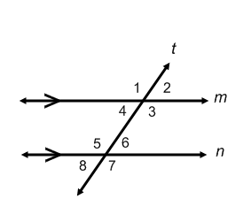3. Given: Line *m* is parallel to line *n* with transversal *t*.

Prove: 

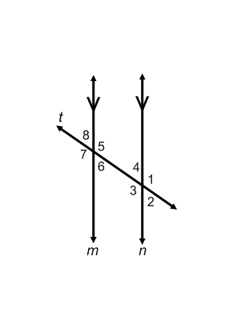

4. Given: Line *m* is parallel to line *n* with transversal *t*.

Prove: 

5. Given: Line *m* is parallel to line *n* with transversal *t*.

 Prove: 



6. Given: Line *m* is parallel to line *n* with transversal *t*.

Prove: 

7. Given: Line *m* is parallel to line *n* with transversal *t*.

 Prove: 



8. Given: Line *m* is parallel to line *n* with transversal *t*.

Prove: 