Math 1 Name ________________________  
**6-6 Congruent Triangles** Date________

Learning Goals:

* *I can use theorems, postulates, or definitions to prove theorems about triangles.*

Determine whether or not you have enough information to say that the following triangles are identical and explain how you know.

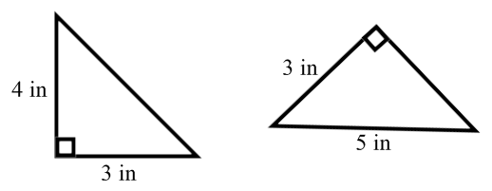

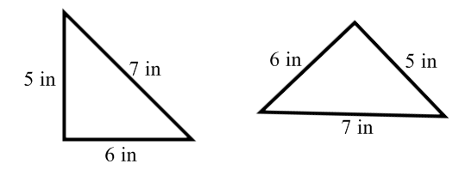1. 2.

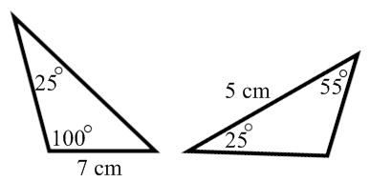

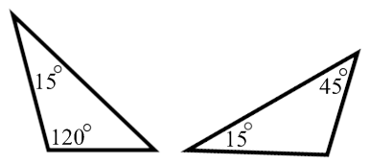3. 4.

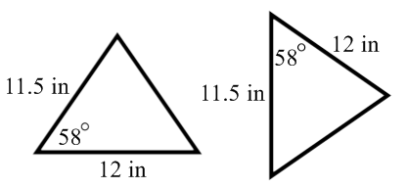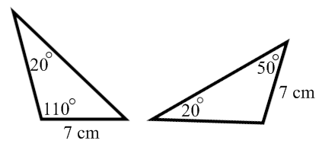

5. 6.

|  |  |
| --- | --- |
|  |  |
|  |  |

|  |
| --- |
|  |

=

+

Equal Symbol

**=**

which means same size

Similar Symbol

**~**

which means same shape

Congruent Symbol



which means…

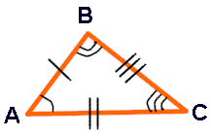**EXAMPLE:**

**NOTE:**

The corresponding congruent sides are marked with small straight line segments called hash marks.   
The corresponding congruent angles are marked with arcs.

The 6 facts for our congruent triangles:

 

 

 

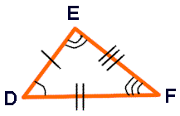

|  |  |
| --- | --- |
|  |  |

http://www.regentsprep.org/Regents/math/geometry/GP4/Ltrian5.gif

The triangles to the right are congruent. Answer the following:

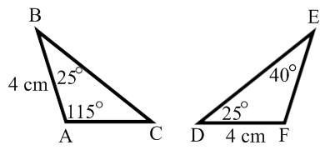7. 

8. 

9. 

10. 

11. 

|  |
| --- |
|  |
| **Six facts for every set of congruent triangles!**  There are certain combinations of the facts that are sufficient to prove that triangles are congruent.   |  |  |  |  |  |  |  |  |  |  |  |  |  |  |  |  |  |  |  | | --- | --- | --- | --- | --- | --- | --- | --- | --- | --- | --- | --- | --- | --- | --- | --- | --- | --- | --- | | |  |  |  | | --- | --- | --- | | **Methods for Proving (Showing) Triangles to be Congruent** | | | | **SSS** | If three sides of one triangle are congruent to three sides of another triangle, the triangles are congruent. (For this method, the sum of the lengths of any two sides must be greater than the length of the third side, to guarantee a triangle exists.) | http://www.regentsprep.org/Regents/math/geometry/GP4/SSS.gif | | **SAS** | If two sides and the included angle of one triangle are congruent to the corresponding parts of another triangle, the triangles are congruent. (The included angle is the angle formed by the sides being used.) | http://www.regentsprep.org/Regents/math/geometry/GP4/SAS.gif | | **ASA** | If two angles and the included side of one triangle are congruent to the corresponding parts of another triangle, the triangles are congruent. (The included side is the side between the angles being used. It is the side where the rays of the angles would overlap.) | http://www.regentsprep.org/Regents/math/geometry/GP4/ASA.gif | | **AAS** | If two angles and the non-included side of one triangle are congruent to the corresponding parts of another triangle, the triangles are congruent. (The non-included side can be either of the two sides that are not between the two angles being used.) | http://www.regentsprep.org/Regents/math/geometry/GP4/AAS.gif | | **HL Right Triangles Only** | If the hypotenuse and leg of one right triangle are congruent to the corresponding parts of another right triangle, the right triangles are congruent. (Either leg of the right triangle may be used as long as the corresponding legs are used.) | http://www.regentsprep.org/Regents/math/geometry/GP4/HL.gif | |  |  | | --- | |  | | |  |  |  | | --- | --- | --- | | **Methods that DO NOT Prove Triangles to be Congruent** | | | | **AAA** | **AAA** works fine to show that triangles are the same SHAPE (similar), but does **NOT** work to also show they are the same size, thus congruent!  Consider the example at the right. | You can easily draw 2 equilateral triangles that are the same shape but are **not** congruent (the same size). | | **SSA** | This is **NOT** a universal method to prove triangles congruent because it cannot guarantee that one unique triangle will be drawn!! | http://www.regentsprep.org/Regents/math/geometry/GP4/assPIC6.gif | |  | |  |  | | --- | --- | |  |  | |  | | | | |  |  | | | |

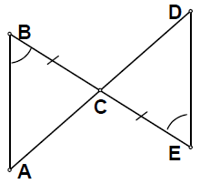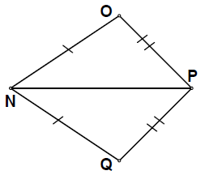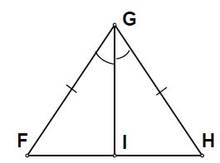For each pair of triangles, state the theorem that can be used to conclude that the triangles are congruent. If you don’t have enough information to say if they are congruent, then say that.

12. 13. 14.

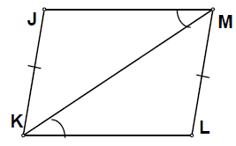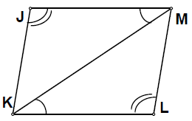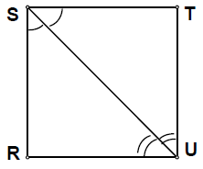15. 16. 17.

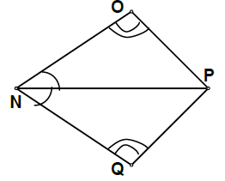For each set of triangles above, complete the triangle congruence statement.

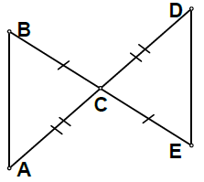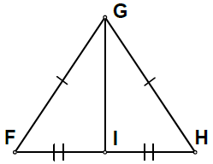18. 19. 20.

  

21. What theorem can be used to justify that the triangles in 18, are congruent?

22. What theorem can be used to justify that the triangles in 19, are congruent?

23. What theorem can be used to justify that the triangles in 20, are congruent?