Math 1 Name ______________________________

**6-6 Practice** Date________

Complete each congruence statement by naming the corresponding angle or side.

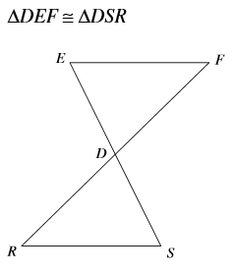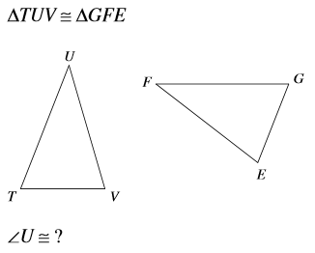1. 2.



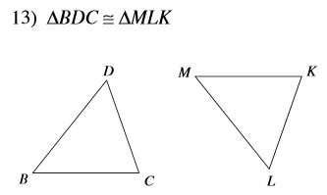Mark the angles and sides of each pair of triangles to indicate that they are congruent.

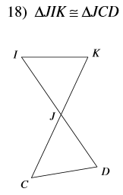3. 4.

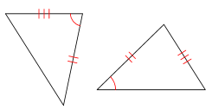State if the two triangles are congruent. If so, what theorem justifies your thinking?

5. 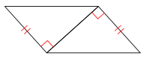 6.

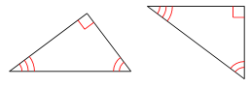7. 8. 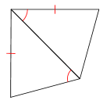

9. 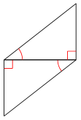 10. 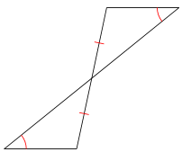

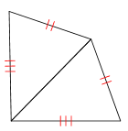

11. 12. 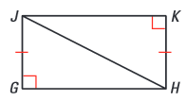

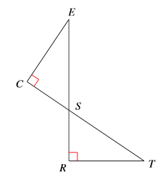State what additional information is required in order to know that the triangles are congruent for the reason given.

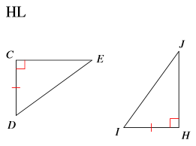13. ASA 14. HL

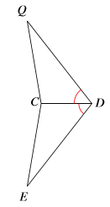

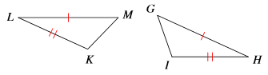15. SAS 16. AAS

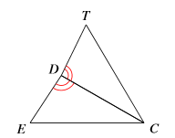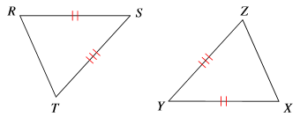17. SSS 18. SAS