Math 1 Name ______________________________  
**6-8 CPCTC** Date________

Learning Goals:

* *I can use theorems, postulates, or definitions to prove theorems about triangles.*



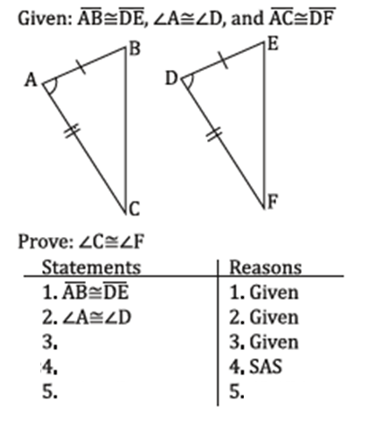1. 2.

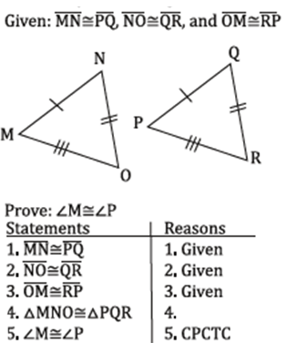



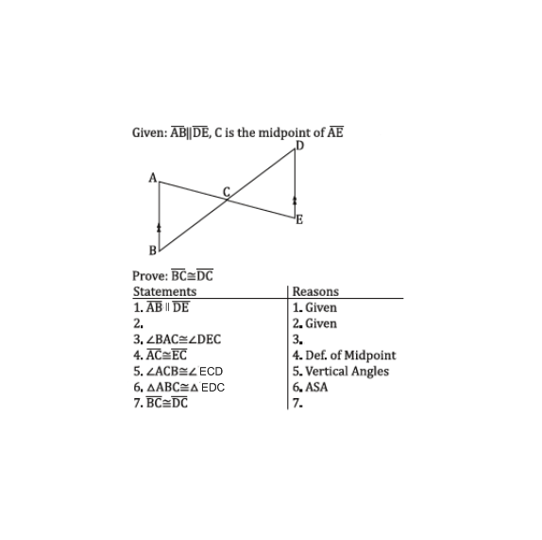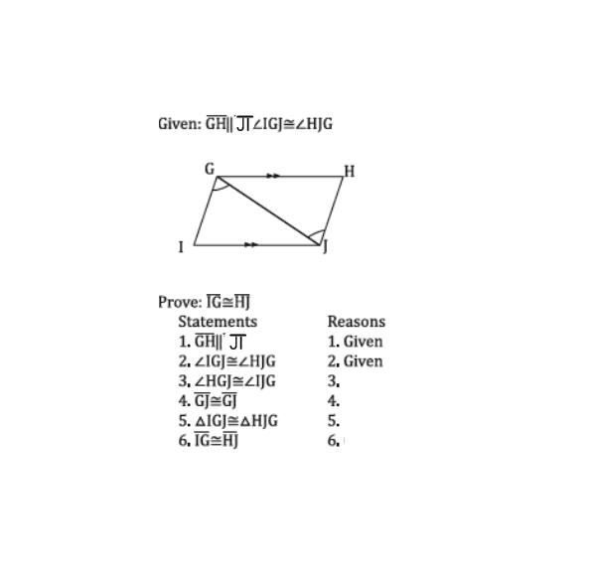3. 4.

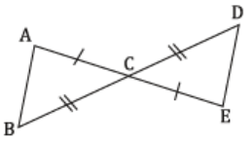5. 6.



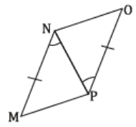



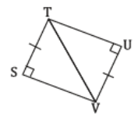7. 8.

