Math 1 Name_______________________________

**7-1 Histograms** Date________

*Learning Goals:*

* I can describe the center and spread of a distribution.
* I can compare two distributions by examining their shapes, centers and spreads.
* I can interpret the differences in the shape, center, and spread of a data set in the context of a problem.
* I can create a histogram.

1. **The data below represents the fat content (in grams) of fast food burgers/sandwiches.**

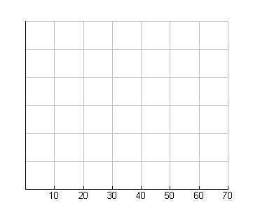a. Make a histogram of the Fat data. Choose appropriate settings for the *Y* values yourself. Be sure to label the *x*- and *y*-axis appropriately:

|  |  |
| --- | --- |
| Fat (g) | |
| 12 | 16 |
| 13 | 7 |
| 18 | 22 |
| 30 | 45 |
| 22 | 16 |
| 29 | 28 |
| 42 | 18 |
| 39 | 5 |
| 69 | 13 |
| 26 | 19 |

NOTES: Look at the notes below on shapes of a histogram.

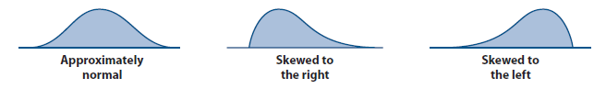

b. Describe the distribution you created above. Be sure to include the *shape, outliers, center, and spread* (***S.O.C.S***.) *You should have at least 4 sentences*

Shape:

Outlier:

Center:

Spread:

2. Use the following data sets to answer the questions below.

|  |  |  |  |  |  |  |  |  |  |  |  |  |  |  |
| --- | --- | --- | --- | --- | --- | --- | --- | --- | --- | --- | --- | --- | --- | --- |
| Player 1 | | | | | | | | | | | | | | |
| 8 | 19 | 19 | 19 | 19 | 18 | 18 | 18 | 17 | 16 | 16 | 15 | 14 | 13 | 20 |

|  |  |  |  |  |  |  |  |  |  |  |  |  |  |  |
| --- | --- | --- | --- | --- | --- | --- | --- | --- | --- | --- | --- | --- | --- | --- |
| Player 2 | | | | | | | | | | | | | |  |
| 11 | 12 | 13 | 14 | 14 | 15 | 15 | 16 | 16 | 17 | 17 | 18 | 19 | 20 |  |

a. Make a histogram for Player 1 and Player 2.

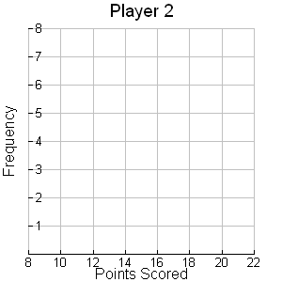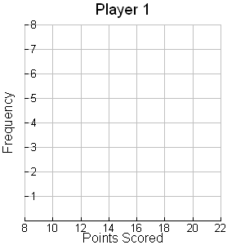

b. Compare the histograms for Player 1 and Player 2. Be sure to mention ***S.O.C.S.*** *You should have at least 4 sentences!*

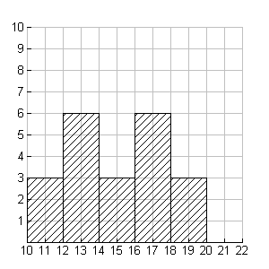c. Below is a histogram of points scored by Player 3 in each game of a season. How many games did Player 3 play? Explain.