Math 1 Name ______________________________
7-3 Analyzing Box Plots Date________

- I can calculate the 5-number summary for a set of data.
- I can describe the center and spread of a distribution.
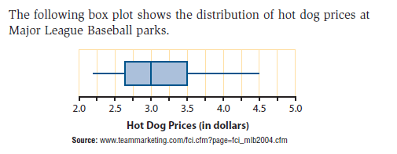
1.

a. What is the shape of the distribution?

b. Estimate the five number summary. Explain what each value tells you about the hot dog prices.

Min = and means that ___________________________________________________.

Q1 = and means that ___________________________________________________.

Q2 = and means that ___________________________________________________.

Q3 = and means that ___________________________________________________.

Max = and means that ___________________________________________________.

2. The following Box Plot represents the data for the number of homeruns that Mr. Pinto’s favorite baseball players hit last year.

Answer the following:

- Describe the distribution.

- What percent of the players hit at least 31 homeruns?

- Why is the left whisker longer than the right whisker?

3. Use the box plots below.
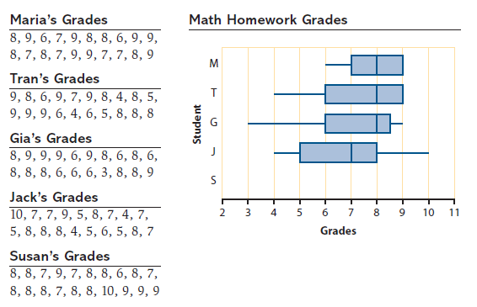

a. Make the box plot for Susan’s grades next to the letter S above.

b. The plots for Maria and Tran have no whiskers at the upper end because. . .

c. Why is the lower whisker on Gia’s box plot so long? Hint: There are NOT more numbers in the
lower whisker.

- The student with the most symmetrical distribution is ____________________.

The students whose distributions are skewed to the left are _______________,

and _______________.

e. The student with the lowest median grade is _____________________.

- The students with the biggest IQR are ___________________ and __________________, and the

student with the smallest IQR is ________________.

g. Does the student with the smallest IQR also have the smallest range? _________

h. What student(s) has/have the largest range? ___________________

i. Based on the box plots, _______________ has the best grades because ______________________

________________________________________________________________________________.

