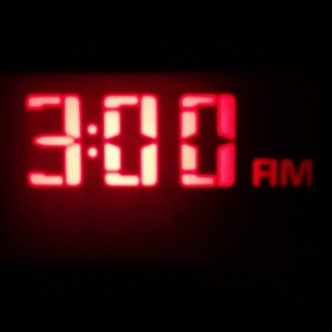
Weekly Agenda – 10/31 – 11/4
British Lit and Comp – McBride
Monday 31- Happy Halloween!
- Collect Structure Sheet
- Assign Synthesis Article
- QW – Things that go bump in the night….muwahahaha….
- 3am…are you ready to be scared??
- HW – Complete Article Assignment by Thursday!
Tuesday 1
- QW – Entrance Slip – RL. 12.5 – Author Structure
- Tune Tuesday - Isa
- The Tragic Hero - +/- Character Trait Chart
- HW – Antigone Test tomorrow! (25 ques/Extend response – Reading Category!) Article Assignment due Thurs!
Wednesday 2
- Antigone Test (Objective/EQ Extended response)
- HW –Article assignment due tomorrow!
Thursday 3
- QW – Priming! Tony Robbins Video (Fill out IQ)
- Conversations - Synthesis Article
- Close Reading Poetry Options
- HW – Read two articles and complete inquiry chart
Friday 4
- Independent Reading
- Close Reading Poetry Options
- Select Choice Articles for Inquiry Chart.
- HW – Read choice articles and complete Inquiry Chart
Learning Goals:
- Analyze how an author's choices concerning how to structure specific parts of a text (e.g., the choice of where to begin or end a story, the choice to provide a comedic or tragic resolution) contribute to its overall structure and meaning as well as its aesthetic impact.
- Cite strong and thorough textual evidence to support analysis of what the text says explicitly as well as inferences drawn from the text, including determining where the text leaves matters uncertain.

Weekly Agenda – 10/31 – 11/4
British Lit and Comp – McBride
Monday 31- Happy Halloween!
- Collect Structure Sheet
- Assign Synthesis Article
- QW – Things that go bump in the night….muwahahaha….
- 3am…are you ready to be scared??
- HW – Complete Article Assignment by Thursday!
Tuesday 1
- QW – Entrance Slip – RL. 12.5 – Author Structure
- Tune Tuesday - Isa
- The Tragic Hero - +/- Character Trait Chart
- HW – Antigone Test tomorrow! (25 ques/Extend response – Reading Category!) Article Assignment due Thurs!
Wednesday 2
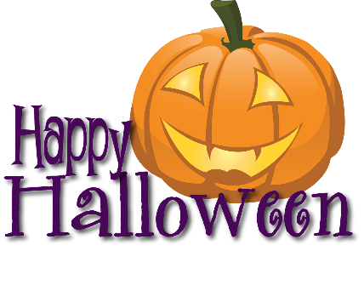
- Antigone Test (Objective/EQ Extended response)
- HW –Article assignment due tomorrow!
Thursday 3
- QW – Priming! Tony Robbins Video (Fill out IQ)
- Conversations - Synthesis Article
- Close Reading Poetry Options
- HW – Read two articles and complete inquiry chart
Friday 4
- Independent Reading
- Close Reading Poetry Options
- Select Choice Articles for Inquiry Chart.
- HW – Read choice articles and complete Inquiry Chart
Learning Goals:
- Analyze how an author's choices concerning how to structure specific parts of a text (e.g., the choice of where to begin or end a story, the choice to provide a comedic or tragic resolution) contribute to its overall structure and meaning as well as its aesthetic impact.
- Cite strong and thorough textual evidence to support analysis of what the text says explicitly as well as inferences drawn from the text, including determining where the text leaves matters uncertain.

