Weekly Agenda 10/4 – 10/7
Brit Lit and Comp – McBride
Tues. 4
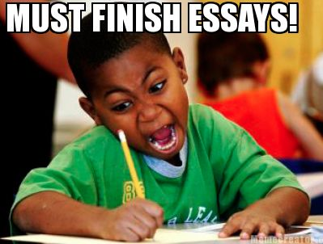
- QW – Read College Crybabies
- Tune Tuesday – sign up
- Tips for writing / revising college essays
  - Polleverywhere/Wordle – what are the most important things to remember?
- Time? Read Sample essays and comments
- HW – Read assigned sample essays (Group A or Group B)
Wed 5 – Senior Pictures!
- QW – Reflect on the sample college essay
- Think / Pair / Share
- Revise essay draft – bring multiple copies for workshop tomorrow!
- HW – Revise your draft using the suggestions from College Admissions Experts!
Thurs. 6
- Writing Workshop
- HW – Final draft due tomorrow. Take time. Show integrity and take pride in your work! Put in your best effort!!
Fri. 7 - Laptops
- Essays due!
- Begin Resume Writing / Sentence diagramming! (You’re welcome, Isa )….
- HW – resumes will be due Tues. Oct. 11! Find an independent reading book for 2nd quarter!
Learning Goals:
W.12.3 - Write narratives to develop real or imagined experiences or events using effective technique, well-chosen details, and well-structured event sequences.
W. 12.4 - Produce clear and coherent writing in which the development, organization, and style are appropriate to task, purpose, and audience. (Grade-specific expectations for writing types are defined in standards 1-3 above.)
W.12.5 - Develop and strengthen writing as needed by planning, revising, editing, rewriting, or trying a new approach, focusing on addressing what is most significant for a specific purpose and audience. (Editing for conventions should demonstrate command of Language standards 1-3 up to and including grades 11-12 here.)

