Weekly Agenda 8/22 – 8/26
Brit Lit and Comp – McBride

Mon 22
- ACT WOTD
- Entrance Slip - Review Author’s Journey – TE (HW/Reading Check)
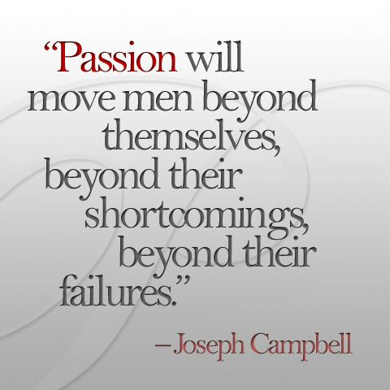
- Introduce Inquiry Chart and process
- HW – Est. your ques. For your IC. Have you read 7MIT?!
Tues. 23
- ACT Word of the Day
- We Could Be Heroes –Work on Inquiry Chart / Blendspace
- HW – Cont. Blendspace work
Wed. 24
- ACT WOTD
- We Could Be Heroes –Work on Inquiry Chart / Blendspace
- HW - Cont. Blendspace work
Thurs. 25
- QW – Read excerpt from Growth Mindset and annotate
- Prep for Tag Team Socratic Seminar…
- HW – Come prepared for seminar tomorrow!
Fri. 26
- ACT WOTD/QW
- Tag Team Seminar
- HW – On-demand essay next week!
LG: CCSS.ELA-LITERACY.SL.11-12.1.A
Come to discussions prepared, having read and researched material under study; explicitly draw on that preparation by referring to evidence from texts and other research on the topic or issue to stimulate a thoughtful, well-reasoned exchange of ideas.
CCSS.ELA-LITERACY.SL.11-12.1.B
Work with peers to promote civil, democratic discussions and decision-making, set clear goals and deadlines, and establish individual roles as needed.
CCSS.ELA-LITERACY.W.11-12.7
Conduct short as well as more sustained research projects to answer a question (including a self-generated question) or solve a problem; narrow or broaden the inquiry when appropriate; synthesize multiple sources on the subject, demonstrating understanding of the subject under investigation.

Weekly Agenda 8/22 – 8/26
Brit Lit and Comp – McBride

Mon 22
- ACT WOTD
- Entrance Slip - Review Author’s Journey – TE (HW/Reading Check)
- Introduce Inquiry Chart and process
- HW – Est. your ques. For your IC. Have you read 7MIT?!
Tues. 23
- ACT Word of the Day
- We Could Be Heroes –Work on Inquiry Chart / Blendspace
- HW – Cont. Blendspace work
Wed. 24
- ACT WOTD
- We Could Be Heroes –Work on Inquiry Chart / Blendspace
- HW - Cont. Blendspace work
Thurs. 25
- QW – Read excerpt from Growth Mindset and annotate
- Prep for Tag Team Socratic Seminar…
- HW – Come prepared for seminar tomorrow!
Fri. 26
- ACT WOTD/QW
- Tag Team Seminar
- HW – On-demand essay next week!
LG: CCSS.ELA-LITERACY.SL.11-12.1.A
Come to discussions prepared, having read and researched material under study; explicitly draw on that preparation by referring to evidence from texts and other research on the topic or issue to stimulate a thoughtful, well-reasoned exchange of ideas.
CCSS.ELA-LITERACY.SL.11-12.1.B
Work with peers to promote civil, democratic discussions and decision-making, set clear goals and deadlines, and establish individual roles as needed.
CCSS.ELA-LITERACY.W.11-12.7
Conduct short as well as more sustained research projects to answer a question (including a self-generated question) or solve a problem; narrow or broaden the inquiry when appropriate; synthesize multiple sources on the subject, demonstrating understanding of the subject under investigation.

