Weekly Agenda 9/26 – 9/30
Brit Lit and Comp – McBride
Mon. 26
- Collect papers
- QW – First impressions (article and response) - Discussion/Take grammar Income
- Intro to Unit 2 – Arming for the Unknown (EQs and LGs)
- HW- Read The Canterbury Tales Context sheet and complete summary statements
Tues. 27
- QW – How do others judge us?
- Review Context of Canterbury Tales (middle ages, Chaucer)
- Assign Canterbury Tales Character Profile
- HW – Complete YOUR profile and your five defining moments
Wed. 28 – Laptops
- Introduce yourself to the World – Read “Crybabies”
- College/Career Readiness…Explore Common App Prompts
- HW – Prewriting –align a defining moment with one of the prompts
Thurs. 29 – Laptops
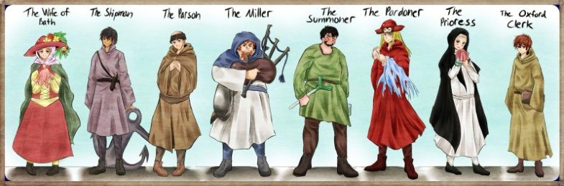
- Check pre-writing
- Read Sample Essays – strengths and weaknesses
- HW – Write first draft of essay
Fri. 30 - Laptops
- Workshop College essays
- Resume writing and LOR
- HW – Revise your draft using the suggestions from College Admission Experts!
Learning Goals:
RL.12.1 – Cite strong and thorough TE to support analysis of what the text says explicitly as well as inferences drawn from the text, including determining where the text leaves matters uncertain.
RL 12.3 – Analyze the impact of the author’s choices regarding how to develop and relate elements of a story or drama (i.e. where the story is set, how the action is ordered, how the characters are introduced and developed)
RL 12.4 – Determine the meaning of words and phrases as they are used in the text, including figurative and connotative meanings; analyze the impact of specific word choices on meaning and tone, including words with multiple meanings or language that is particularly fresh, engaging or beautiful.
W.12.3 - Write narratives to develop real or imagined experiences or events using effective technique, well-chosen details, and well-structured event sequences.

Weekly Agenda 9/26 – 9/30
Brit Lit and Comp – McBride
Mon. 26
- Collect papers
- QW – First impressions (article and response)- Discussion/Take grammar Income
- Intro to Unit 2 – Arming for the Unknown (EQs and LGs)
- HW- Read The Canterbury Tales Context sheet and complete summary statements
Tues. 27
- QW – How do others judge us?
- Review Context of Canterbury Tales (middle ages, Chaucer)
- Assign Canterbury Tales Character Profile
- HW – Complete YOUR profile and your five defining moments
Wed. 28 – Laptops
- Introduce yourself to the World – Read “Crybabies”
- College/Career Readiness…Explore Common App Prompts
- HW – Prewriting – align a defining moment with one of the prompts?
Thurs. 29 – Laptops
- Check pre-writing
- Read Sample Essays – strengths and weaknesses
- HW – Write first draft of essay
Fri. 30 - Laptops
- Workshop College essays
- Resume writing and LOR
- HW – Revise your draft using the suggestions from College Admission Experts!
Learning Goals:
RL.12.1 – Cite strong and thorough TE to support analysis of what the text says explicitly as well as inferences drawn from the text, including determining where the text leaves matters uncertain.
RL 12.3 – Analyze the impact of the author’s choices regarding how to develop and relate elements of a story or drama (i.e. where the story is set, how the action is ordered, how the characters are introduced and developed)
RL 12.4 – Determine the meaning of words and phrases as they are used in the text, including figurative and connotative meanings; analyze the impact of specific word choices on meaning and tone, including words with multiple meanings or language that is particularly fresh, engaging or beautiful.
W.12.3 - Write narratives to develop real or imagined experiences or events using effective technique, well-chosen details, and well-structured event sequences.

