Beaver
Castor canadensis
Tracks and sign  Range: Most of the U.S.  Habitat: Ponds, creeks, other riparian areas  Size: 45 to 60 pounds  Young: Litter of 4-6 born in May/June  Tracks: Front 2-3 inches long, hind 5-7 inches long  Scat: 1½ to 2½ inches long, not often found on land. They defecate in the water.  Stride: 6-11 inches  Diet: Cattail shoots, parts of pond lilies and other aquatic vegetation, and the bark of trees (willow, aspen, birch, alder) | Narrative  The beaver is a familiar animal that inhabits most of the U. S. They are found just about everywhere except most of California, most of Florida and Nevada, and parts of Alaska. There are some isolated populations of beaver reported to be in Riverside County, California, in Temecula Creek. Beavers appear to be expanding their range. This is one of the largest rodents. Beavers weigh 45 to 60 pounds. Historically, beavers weighing over a hundred pounds were common.  Beavers are well-known as the builders of dams and lodges. Their long incisor teeth help them to cut down trees by gnawing their way all the way around the tree trunk. Beaver dams back up the water into ponds which change the habitat of that area. The ponds create marshy areas which allow certain trees to grow. These in turn support different species of wildlife that can live in a riparian environment. Over time, a beaver pond will become a meadow, then shrubs will begin to grow. The shrubs will provide shade that allows tree seedlings to get started. Once these trees grow tall enough, they shade out the shrubs. The trees will eventually grow into a mature forest. This cycle is called forest succession and many factors play a part, but the beaver helps to begin the process by building its dams, which back up water, slow sediment, and allow it to settle and build up.  Lodges are dome-shaped and are built in deep water. Lodges are built with wide bases, sometimes up to 20 feet wide. The top can stand ten feet high. Entrances are under water and the beavers swim away from the lodge before surfacing. Dams and lodges are constructed of interwoven branches and mud. The water behind the dam generally is backed up to a depth of four to six feet. Dams can be wide, often five feet or more. The length of the dam depends upon the width of the stream.  Beaver ponds provide habitat for various species of fish, and other mammals, such as otters, that feed on the fish. Ospreys and other birds will nest in the dead snag trees that are killed by the flooding caused by the beaver pond. These birds feed on the fish in the pond.  Toppled trees are an obvious sign of beaver activity. A groove is gnawed all the way around the trunk in an hourglass shape. The downed trees are stripped of bark. Trees of a diameter approaching three feet can be felled by beavers.  Beaver pelts are thick and lustrous, factors which led to extensive trapping of beavers for both their pelts and their meat. The fatty tail, which is reputed to be very good tasting, was once considered to be a delicacy. In many areas, beavers had been exterminated by trapping by the 1900s. Trapping regulations were enacted to protect beavers and this drove up the price of beaver pelts, making them unaffordable to most people.  The beaver’s preferred habitat is near water. They love aspen, birch, willow, cottonwood, basswood, and poplar trees. The trees are used as building material as well as food. Beavers are vegetarians. They eat cattail shoots, parts of pond lilies and other aquatic vegetation, and trees. They don’t really eat the wood, just the bark. An adult beaver can fell a tree 10 inches in diameter in about six minutes.  Beavers stash trees underwater for use during the winter. They will drag a limb down and plant the heavy end in the mud at the bottom of the pond. When the pond is frozen over and it is hard to find food, the beaver can take advantage of this stash.  Beaver kits are born in May and June. Litter size is usually about four. The health of the mother beaver influences how many kits are born. If she has had good nutrition and an abundance of food, a larger litter size is possible. The babies are about one pound at birth and are born with a full coat of fur and their eyes open. Kits can swim, but it may take them a month or more to figure out how to hold their breath and swim underwater. When they get tired, they catch a ride on their mother’s back.  Beavers mate for life. The older kits may help care for and defend the younger ones. Because beavers are social animals, there can be as many as 18 beavers in one pond. When they are about two years old, beavers go in search of their own territory. They may wander ten miles to find a location to build a new pond.  Since beavers live near water, their tracks are often found in mud, which gives good detail to the prints. Beaver tracks show webbing on the hind feet. Hind tracks can easily be six to seven inches long. All feet have five toes. The prints show five toes on the hind feet and four toes on the front feet. The fifth front toe sometimes registers, but not on all surfaces. Front tracks can be two to three inches long. Claw marks show in the tracks. Beavers walk plantigrade, or flat-footed. The large tail sometimes leaves a drag mark in the trail. Beavers can run at six to eight miles per hour. Beavers groom their fur with an oily substance called castoreum which comes from glands. This is the substance that gives the animal's fur its waterproof qualities.  Beaver scat is commonly deposited in the water. When it is deposited on land, it is on the edge of the water. Scat appears composed of sawdust and is cylindrical. The segments are 1½ to 2½ inches long.  Beavers establish scent posts near their ponds. These are composed of a mound of mud, grass and sticks piled up into a dome-shaped mass. The beaver rubs castoreum on the mound. Some of these mounds can be huge, measuring a foot tall and three feet across.  The main predators of beavers are foxes, owls, otters, hawks, alligators, bobcats, coyotes, and lynx. Adult beavers are good fighters and most predators leave them alone.  Beavers maintain their dams so that the pond water level stays up. If a dam breaks, the beavers will frantically rush to repair it before all the water rushes away.  Beavers don’t make much sound. The young can make sounds that resemble a duck quacking. They also whine and make several other noises. Adults sometimes grunt while working, but are generally silent. One sound beavers are well-known for making is the tail slap. To warn other beavers of danger, the tail will be brought down flat against the water to make a loud slapping sound.  Beavers have a nictating membrane that protects their eyes.

Beaver Tracks and Sign
3 in. L X 2.75 in. W | 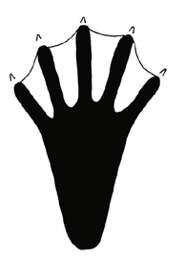  5 in. L X 5.5 in. W
Beaver front track. Front tracks look similar to raccoon tracks. | Beaver hind track. Webbing between toes helps beavers swim.
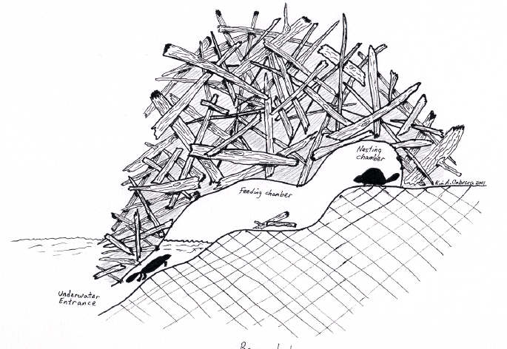
Diagram of beaver lodge showing various chambers. Lodges are built with underwater entrances. Mud is used to hold the branches together. Beavers sometimes construct burrows in banks near water. They also create dams to back up water into ponds.
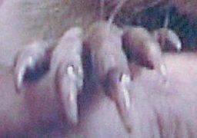
Beaver claws
Copyright © Kim A. Cabrera 2004

