Mary Cassatt
The Boating Party
Submitted by: Patty Lehrman -2016

Today for our Art Docent Presentation we studied the artist Mary Cassatt and her famous painting, “The Boating Party.” After a discussion of the artist and her works we pretended that we were on a sail boat rowing the lake. We talked about how we felt, what we saw, heard and smelled along our journey, and how we might use all of those factors to create a work of art. We then constructed sail boats and raced them (2 at a time), powered by the students blowing air through straws! A singing round or two of “Row, Row, Row Your Boat” was also enjoyed by all!

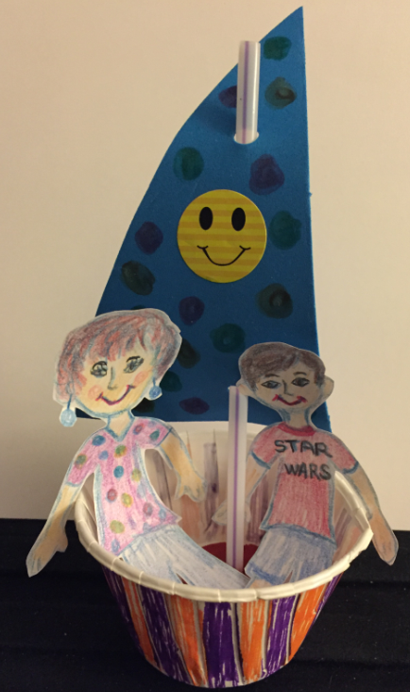
Paper Boats
- Nut cups
- Straws for the sails and for racing the boats if you choose to do so
- Stickers (optional)
- Pre-cut sails - hole punched
- White copy paper – crayons – markers- scissors
- Clay to anchor the straws in

I told students to draw themselves and someone that they would like to take along for their boating party! They chose to take anyone from their grandparents, siblings, pets, and even characters from Star Wars!

