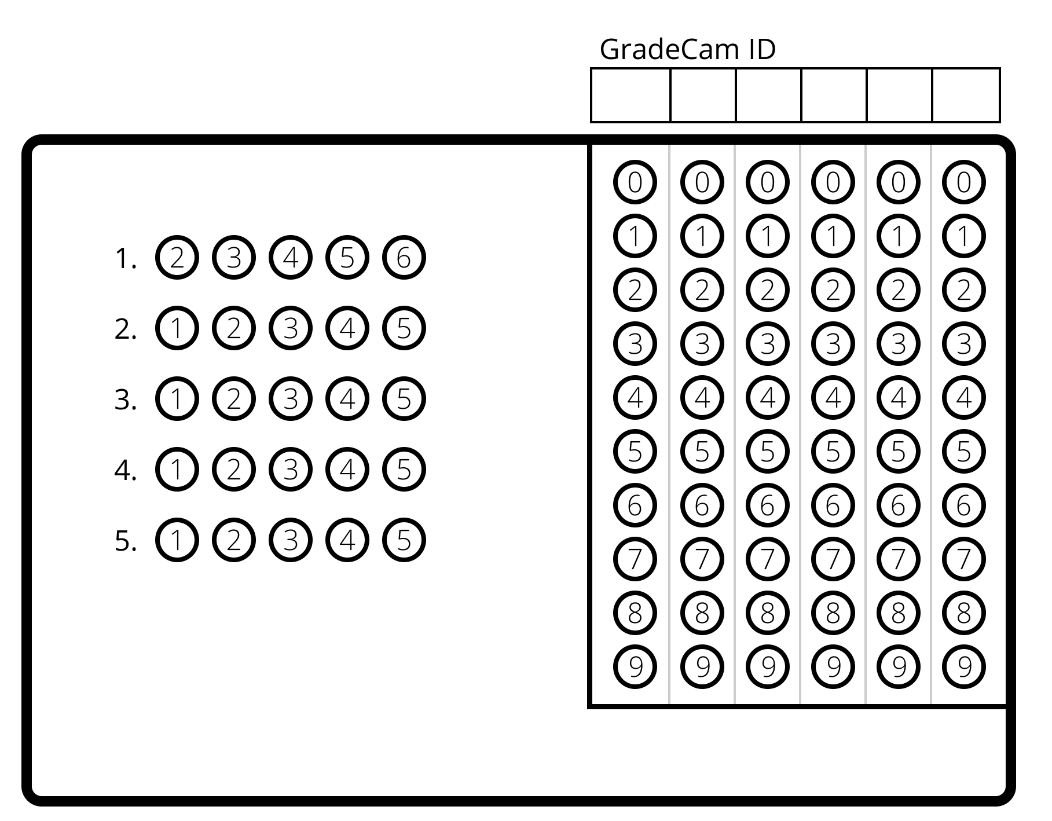
Learning Goals: SWBAT
- Understand the process of cellular respiration.
- Understand the interdependence of cell respiration and photosynthesis.
Level 2
- Write the balanced chemical equation for cellular respiration. Label the reactants and products.
C₆H₁₂O₆+6O₂ 30-36ATP/ENERGY + 6CO₂ +6H₂O
Reactants Products
- Fill in the chart below that outlines the 3 stages of cellular respiration. Please list them in order!
Stage of Cellular Respiration | Where does it take place? | Aerobic or Anaerobic?
Glycolysis | Cytoplasm | Anaerobic
Krebs (Citric Acid) Cycle | Matrix of mitochondria | Aerobic
Electron Transport Chain | Cristae of mitochondria | Aerobic

Level 3
- Which stage of cellular respiration produces the most ATP and WHY/HOW?
1 Last phase of aerobic cell respiration, Electron transport chain produces the most energy in ATP because it receives high energy electrons from the previous stages.
2 Electrons in covalent bonds of organic compounds in food store chemical pot energy.
3 As covalent bonds in organic food molecules are broken during glycolysis and Kreb’s cycle, they & the energy they possess are loaded onto empty electron carriers, NAD+ or FAD+, producing high energy, filled electron carriers NADH and FADH₂.
4 Neither glycolysis or Kreb’s cycle directly provide much ATP, only 2 ATP per stage.
5 NADH and FADH₂ transfer energy rich electrons to the electron transport chain proteins which convert energy, ultimately fueling operation of enzyme ATP synthase which catalyzes endothermic: 30⁺ ADP + 30⁺ Phosphate 30⁺ ATP + some heat
- Explain why eukaryotic producers contain both chloroplasts and mitochondria whereas eukaryotic heterotrophs only have mitochondria
1 Producers carry out photosynthesis in chloroplasts, making sugars.
2 Producers can’t use sugar to do work; they have to use ATP.
3 Producers must use sugar to make ATP through cell respiration in their mitochondria.
4 Heterotrophs don’t do photosynthesis, so they don’t need chloroplasts.
5 Heterotrophs obtain energy by eating other organisms or the organic molecules made by other organisms.
6 But heterotrophs still require ATP to do cell work, so they must carry out cell respiration to convert chemical potential energy of their foods to chemical potential energy in ATP; for this, they use aerobic cell respiration in their mitochondria.

