AP Biology Name __________________________
Guided Reading Chapter 26

There are those who see the future of taxonomy abandoning the kingdom – phylum – class, etc. system altogether. This chapter introduces classifications with a greater understanding of molecular biology.

- Define the following terms:
  - Phylogeny
  - Systematics
  - Molecular systematics
  - Homoplasies
  - Taxonomy
  - Binomial nomenclature
  - Phylogenetic trees
  - Cladogram
  - Clade
  - Cladistics
  - Shared ancestral character
  - Shared derived character

- Use the following blank diagram to compare and explain monophyletic, paraphyletic and polyphyletic – include the definition of each term in your diagram
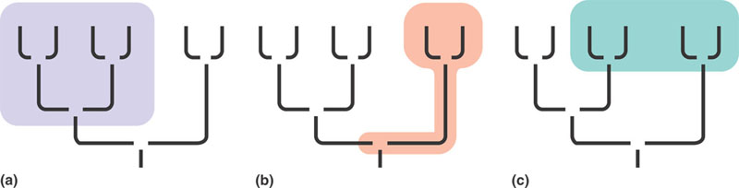
- What is the relationship between the ingroup and the outgroup in classification?
- What does parsimony mean?
- How is this applied to understanding evolution – what is the principle of maximum parsimony and the principle of maximum likelihood?
- What is the concept of a molecular clock and how is it useful?

- What domains have been agreed upon?

