**Chapter 11 Study Guide**

**Vocabulary**

**Understand and be able to apply the definitions to the following terms:**

acids

bases/alkaline

colloids

concentrated solution

concentration

corrosive

dilute solution

filtration

heterogeneous

homogeneous

indicator

mixtures

neutralization

pH

saturated solution

solubility

solute

solutions

solvent

suspension

unsaturated solution

***INTERPRET/ANALYZE GRAPH***



At what temperature is a solution saturated if it contains 100g of KNO3

dissolved in 100g of water?

A. 45°C

B. 58°C

C. 90°C

D. 29°C

If 60g of NaCl were mixed in 100 g of water at 90o C which type of solution would this be?

A. unsaturated

B. supersaturated

C. saturated

D. suspension

***CALCULATING CONCENTRATION***

Calculate the concentration (%) of 50 grams of sugar in 175 mL of water .

50 / 225 x 100% = 22%

Describe what occurs when you combine oil and water. What type of mixture is it? Is it an example of a homogeneous or heterogeneous mixture?

When oil and water combine they do not mix. They form a suspension which is an example of a heterogeneous mixture.

How could you increase the amount of solute that is dissolved in a given substance?

You can increase the amount of solute that dissolves in a substance by increasing the amount of solvent, increasing the temperature, or increasing the pressure of the solution.

Identify the factors that affect solubility:

1. Temperature of the solution
2. Pressure acting on the solution
3. Stirring the solution

***Complete the table below:***

|  |  |  |
| --- | --- | --- |
| ***Properties*** | ***ACIDS*** | ***BASES*** |
| Reaction with Metals | Corrosive/wears it away | NONE |
| Reaction with Carbonates | Produces a salt, water, and releases carbon dioxide | NONE |
| Taste | Sour | Bitter |
| Reaction with Litmus Paper | Red stays Red  Blue turns Red | Blue stays Blue  Red turns Blue |
| Uses/Examples | Lemon, lime, grapefruit, HCl, fertilizers | Soap, Ammonia, NaOH, cleaning surfaces,detergents, acid relievers |

**Directions**: Fill in the blank with the best possible answer.

1. Four ways to separate a mixture are hand separation, screening, __filtration__________, and evaporation.
2. Soluble or solubility refers to how much of a ___________solute______ can be dissolved in a solvent.
3. A _saturated _____ solution is when no more solute will dissolve into the solvent so it settles to the bottom.
4. You can neutralize a (n) ____acid_________________ by adding a base.
5. Concentration is the amount of a solid compared to the amount of liquid. An example would be 50 g of sugar in 200 mL of water equals _________50 / 250 x 100% = 20%____________________.
6. To increase the concentration one would add more solute to the solvent. If the solvent is saturated

the concentration can only be raised by increasing the temperature of the solution.

1. To separate a solution you have to ___evaporate_____________ the ____solvent_____.
2. Weak tea is an example of a ______dilute___________________________ solution.
3. The compound that changes color in an acid is called __indicator (litmus paper)___________.
4. An acid would turn red litmus paper ____red_______________________.
5. A base would turn blue litmus paper ____blue_______________________.
6. An acid would turn blue litmus paper ____red______________________.
7. A base would turn red litmus paper _____blue______________________.
8. Because it wears away certain materials, an acid is described as _corrosive_______________.
9. Many soaps and detergents contain __bases__________________.
10. Because vinegar contains a(n) ____acid______________,it tastes sour.
11. When a substance’s value is below 7 on a pH scale this is called a(n)__acid______________.
12. When a substance’s value is higher than 7 on a pH scale this is called a(n)__base_______________.
13. When a substance’s value is 7 on a pH scale this is called __neutral_______________.

Directions: Below list 4 substances that would be considered an acid.

1.___HCl__________________

2.____Vinegar_________________

3.___Lemon Juice_________________

4.____Tomato Juice_________________

Below list 4 substances that would be considered a base/alkaline.

1.____soap_________________

2.____ammonia__________________

3.___laundry detergent___________________

4.____Tums_________________

**Directions:** Create a Venn Diagram comparing and contrasting a saturated solution and a suspension.

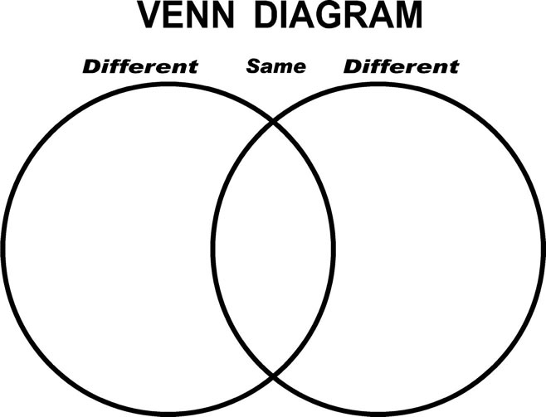

Use the following term(s) to complete the venn diagram:

Dissolved particles Particles at the bottom No dissolved particles

Heterogeneous Mixture Can physically separate Cannot physically separate

Separate by evaporating the solvent Includes more than one substance