**Chapter 11 Study Guide**

**Vocabulary**

**Understand and be able to apply the definitions to the following terms:**

acids

bases/alkaline

colloids

concentrated solution

concentration

corrosive

dilute solution

filtration

heterogeneous

homogeneous

indicator

mixtures

neutralization

pH

saturated solution

solubility

solute

solutions

solvent

suspension

unsaturated solution

***INTERPRET/ANALYZE GRAPH***



At what temperature is a solution saturated if it contains 100g of KNO3

dissolved in 100g of water?

A. 45°C

B. 58°C

C. 90°C

D. 29°C

If 60g of NaCl were mixed in 100 g of water at 90o C which type of solution would this be?

A. unsaturated

B. supersaturated

C. saturated

D. suspension

***CALCULATING CONCENTRATION***

Calculate the concentration (%) of 50 grams of sugar in 175 mL of water .

Describe what occurs when you combine oil and water. What type of mixture is it? Is it an example of a homogeneous or heterogeneous mixture? __________________________________________________________________________

__________________________________________________________________________

__________________________________________________________________________

__________________________________________________________________________

__________________________________________________________________________

__________________________________________________________________________

How could you increase the amount of solute that is dissolved in a given substance?

__________________________________________________________________________

__________________________________________________________________________

__________________________________________________________________________

__________________________________________________________________________

__________________________________________________________________________

Identify the factors that affect solubility:

1. ______________________________________________
2. ______________________________________________
3. ______________________________________________

***Complete the table below:***

|  |  |  |
| --- | --- | --- |
| ***Properties*** | ***ACIDS*** | ***BASES*** |
| Reaction with Metals |  |  |
| Reaction with Carbonates |  |  |
| Taste |  |  |
| Reaction with Litmus Paper |  |  |
| Uses |  |  |

**Directions**: Fill in the blank with the best possible answer.

1. Four ways to separate a mixture are hand separation, screening, _________________________, and evaporation.
2. Soluble or solubility refers to how much of a ______________________ can be dissolved in a solvent.
3. A _________________________ solution is when no more solute will dissolve into the solvent so it settles to the bottom.
4. You can neutralize a _____________________ by adding a base.
5. Concentration is the amount of a solid compared to the amount of liquid. An example would be 50 g of sugar in 200 mL of water equals _____________________________.
6. To increase the concentration one would add more solute to the solvent. If the solvent is saturated

the concentration can only be raised by ________________________solute to the solution.

1. To separate a solution you have to _______________________ the ___________________.
2. Weak tea is an example of a _________________________________ solution.
3. The compound that changes color in an acid is called ________________.
4. An acid would turn red litmus paper ___________________________.
5. A base would turn blue litmus paper ___________________________.
6. An acid would turn blue litmus paper __________________________.
7. A base would turn red litmus paper ___________________________.
8. Because it wears away certain materials, an acid is described as ________________.
9. Many soaps and detergents contain ____________________.
10. Because vinegar contains a(n) __________________,it tastes sour.
11. When a substance’s value is below 7 on a pH scale this is called a(n)________________.
12. When a substance’s value is higher than 7 on a pH scale this is called a(n)_________________.
13. When a substance’s value is 7 on a pH scale this is called _________________.

Directions: Below list 4 substances that would be considered an acid.

1._____________________

2._____________________

3.____________________

4._____________________

Below list 4 substances that would be considered a base/alkaline.

1._____________________

2.______________________

3.______________________

4._____________________

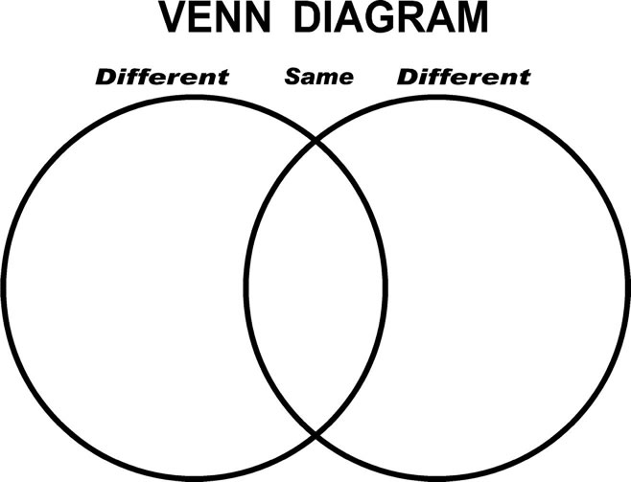**Directions:** Create a Venn Diagram comparing and contrasting a saturated solution and a suspension.