AP Calculus AB Name_____________________________________

Chapter 2 Extra Practice Problems Date __________________________________

**NO CALCULATOR**

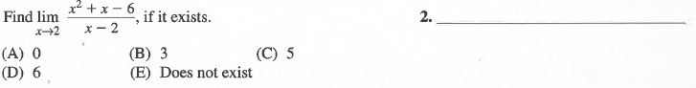

1.

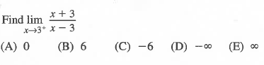

2.

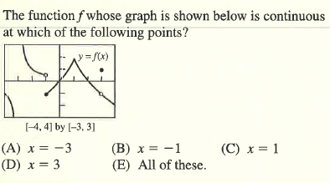

3.

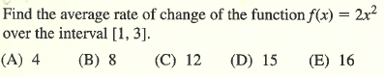

4.

5. Assume and . Find 

(A)  (B)  (C)  (D)  (E) 

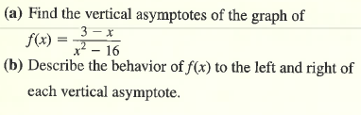

6.

OVER 🡪

7. Find the points of discontinuity of the function 

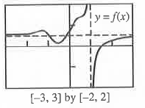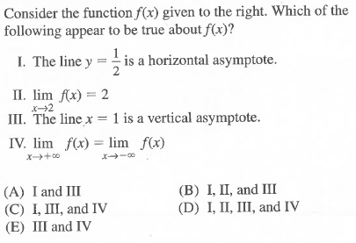

8.

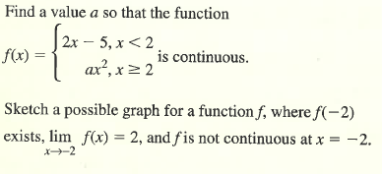

9.

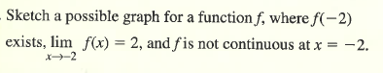

10.

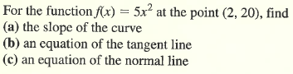

11.

**CALCULATOR ACTIVE**

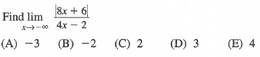

12.

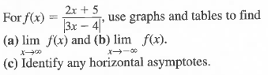

13.

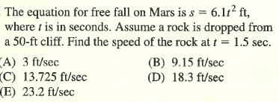

14.