AP Calculus AB Chapter 2 Test Review

**Station #1: Limits & Continuity**

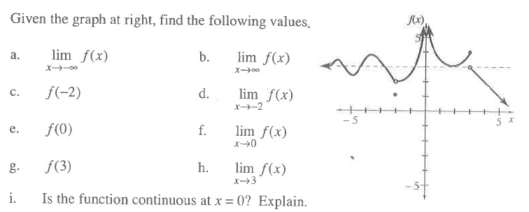

1.

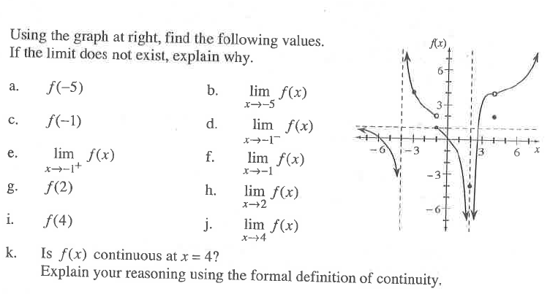

2.

AP Calculus AB Chapter 2 Test Review

**Station #2: Rates of Change**

For the function  find:

a. the slope of the curve at  **using the definition (long-show-your-work way!)**

b. an equation of the tangent line

c. an equation of the normal line

AP Calculus AB Chapter 2 Test Review

**Station #3: NO CALCULATOR Practice**

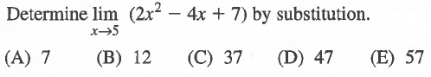

1.

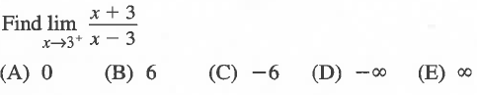

2.

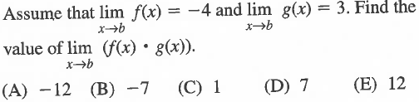

3.

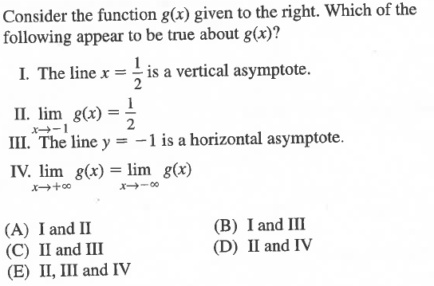

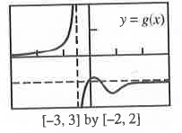4.

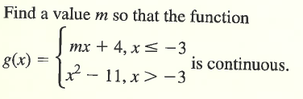

5.

AP Calculus AB Chapter 2 Test Review

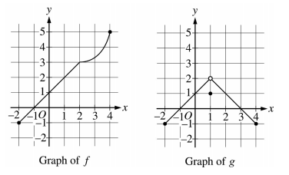**Station #4: NO CALCULATOR Practice**



1. .



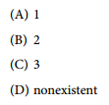

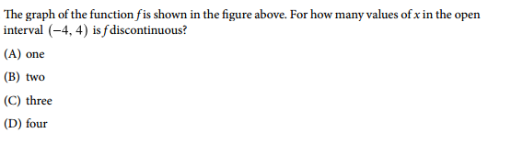

2.

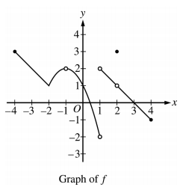

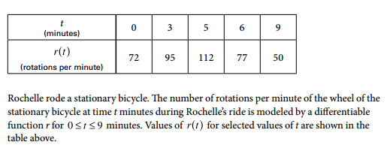

3.



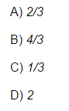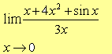

4. Find .