AP Calculus AB Name__________________________________
Chapter 5 Test Review Date _________________________________

MULTIPLE CHOICE
NO CALCULATOR
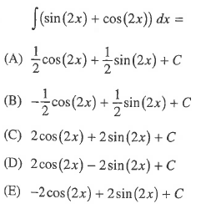
1.

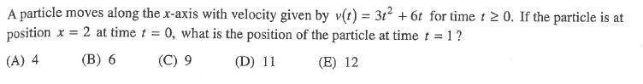
2.

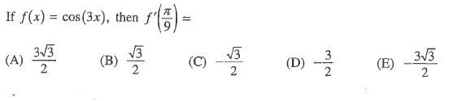
3.

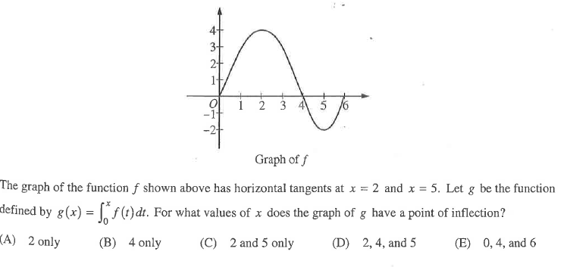
4.

OVER
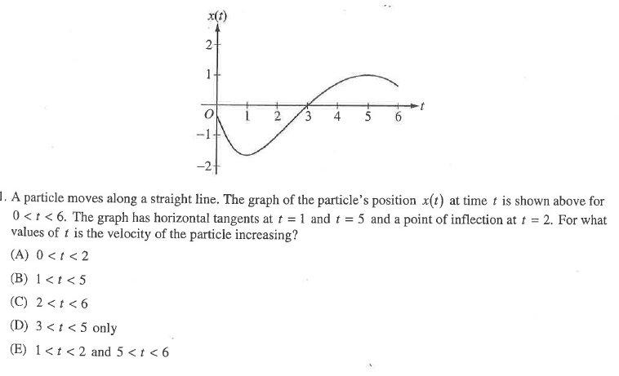
5. Page 2

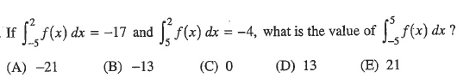

6.

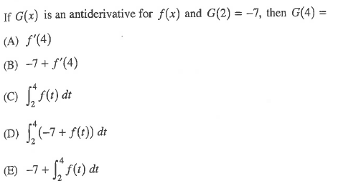
7.

Page 3
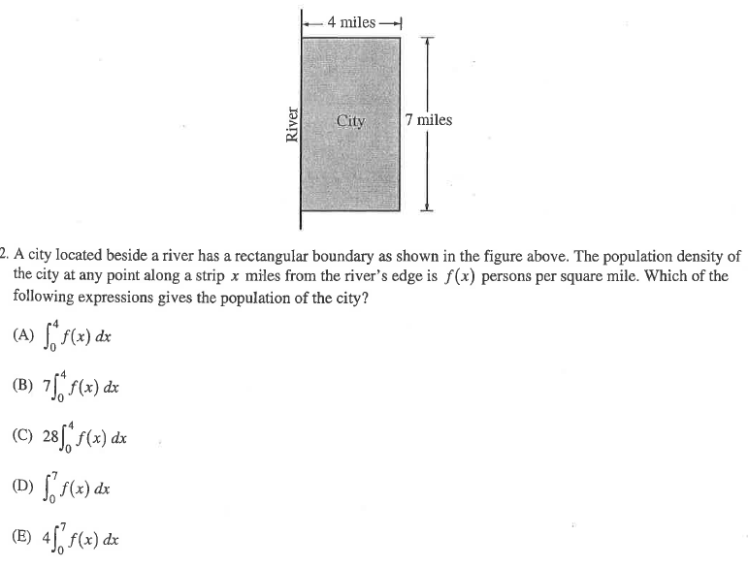
8.

FREE RESPONSE
NO CALCULATOR
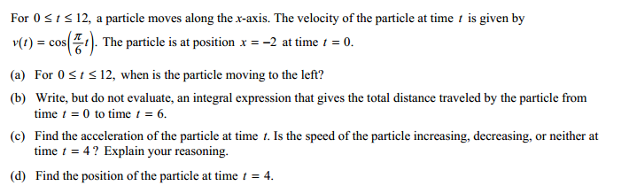
1.

OVER
Page 4
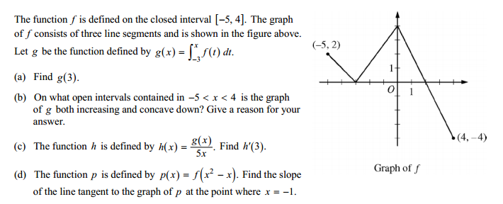
NO CALCULATOR
2.

CALCULATOR ACTIVE
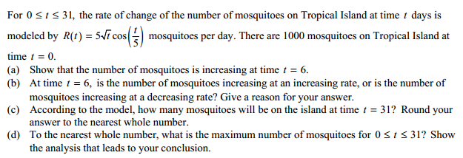
3.

