AP Calculus AB Name__________________________________

Chapter 7 Test Practice (with review) Date _________________________________

Evaluate the following integrals.

1.  2. 

3.  4. 

5.  6. 

OVER 🡪

Page 2

7. Consider the differential equation  Let *y* = *f*(*x*) be the particular solution to this differential equation with the initial condition *f*(-1) = 2.

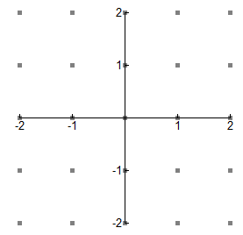a) On the axis below, sketch a slope field for the given differential equation at the points indicated. Sketch the particular solution for 

b) Find the solution *y = f*(*x*) to the given differential equation with the initial condition

*f*(-1) = 1.

8. Find 

Page 3

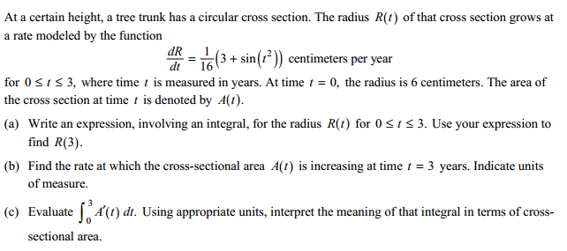9. AP Free Response – **CALCULATOR ACTIVE**

OVER 🡪

Page 4

10. **2016 AP Exam – No Calculator**

