**Station 1 *NO CALCULATOR***

**Differentiate each function below.**

1.  2. 

*Write your answer in factored form.*

3. *y =* 13-2*x* 4. *y* = sin-1(2 – *x*)

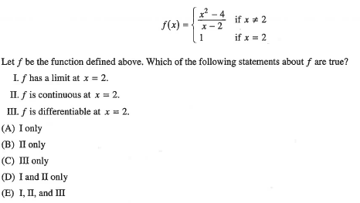**Station 2 *NO CALCULATOR***

1.

2. Differentiable functions *f* and *g* have the values in the table. *\*\*\*Write your formula first!!!*

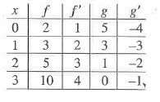

1. 

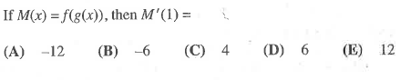

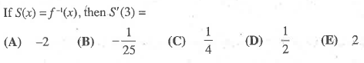

b.

**Station 3 *NO CALCULATOR***

1. If  then 
2. 1/3 B.) -2/3 C.) 1 D.) 4/3 E.) 3
3.  ______.
4.  B.)  C.)  D.)  E.) 
5. If  Find the slope of the tangent line when *x* = 1.





1. A) -2 B) -π/2 C) -2/π D) DNE

**Station 4  *NO CALCULATOR***

1. If  then the value of  at (1, 2) is

(A) -3 (B) -1 (C) 2 (D) 5 (E) None of the above.

Write the equation of the normal line at (1, 2).

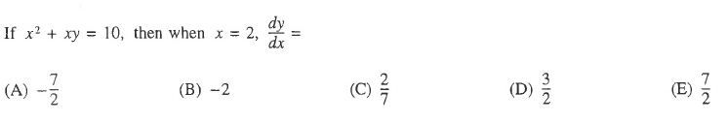

2.



**Station 5  *NO CALCULATOR***

Basics you must know!

1. *Math 2!!!!*

    

    

1. *Do not draw a unit circle!*

   

   

1. *Do not touch your calculator!*

   

   

-1/2 – 1 = -1 – 1 = -1/3 – 1 = -2/3 – 1 =



Calculate the slope of the line going through the points (-3, -8) and (10, -4) .