AP Calculus AB Name____________________________________

Chapters 3 & 4 Test Review Date ________________________________

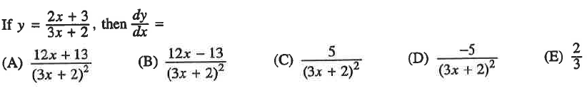

1.

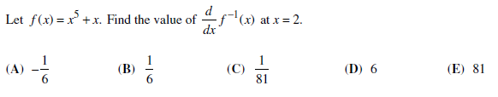

2.

***Hint: You will have to use your calculator

To help solve an equation.

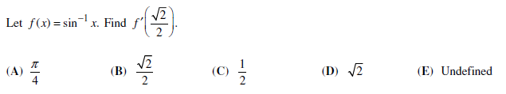

3.

4. Let *f* be the function defined by . Which of the following is an equation of the line tangent

to the graph of *f* at the point where 

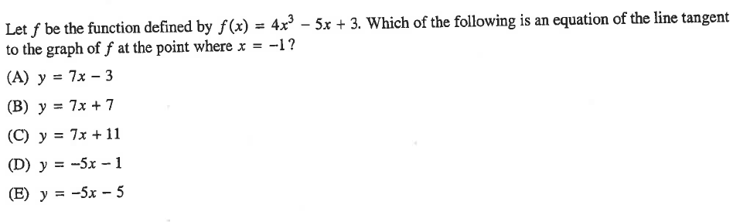

5. Let *f* be a differentiable function with and , and let *g* be the function defined b

. Which of the following is an equation of the line tangent to the graph of *g* at the point where **.

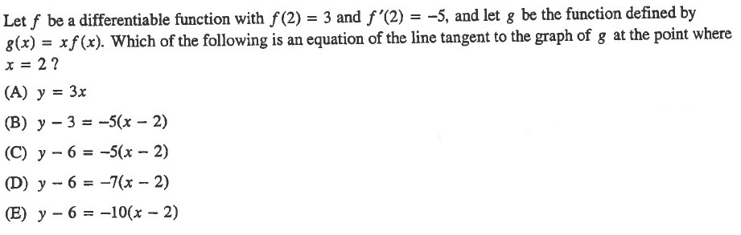

OVER 🡪

6. Differentiate the following.



7. Differentiate the following. ***Do not simplify!***

9b.

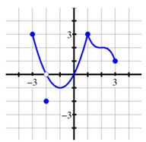



8. Find if 



9a. Evaluate:

