Chipmunks
Tamias spp.
Tracks and sign  Range: Most of U.S.  Habitat: Forests, mountains, plains  Size: 3.5 to over 6 inches long, 1 to 4.5 ounces  Young: One litter of four to eight per year.  Tracks: Four toes on front feet, five toes on hind  Scat: Somewhat round pellets, 1/4 inch long  Stride: 4-23 inches  Diet: Seeds, fungi, berries, acorns, insects, bird eggs | Narrative  Chipmunks have stripes on the back and cheeks. Usually, there are four dark and five light stripes. Depending on species, they range from 3.5 to over 6 inches long, and can weigh 1 to 4.5 ounces. Chipmunks have pouches in their cheeks for carrying food.  Chipmunks are relatively shy. They are active all day and often sun themselves in trees. They are good climbers, often running up trees to flee predators. They spend most of their time on the ground though. This is where they forage for food and have their burrows. They will also store food in the burrows. During the cold winter months, chipmunks may go into their burrows and go into a state of torpor, but they don't hibernate. They do wake up and eat during this time.  The home range is about 1½ acres. Chipmunks eat berries, acorns, maple seeds, conifer seeds, fungi, and insects. They will even eat bird eggs.  Chipmunks produce only one litter of young per year. They are born in May or June. The babies are born without fur and their eyes are closed. They also lack teeth. They are tiny, weighing only about 1/10 ounce each.  Common predators include the bobcat, gray fox, weasel, skunks, owls, and mink. Some of the chipmunks in campgrounds become bold and will raid picnic tables and carry off food after stuffing it into their cheek pouches. In winter, they will hole up with a food cache, but they don't hibernate.  Tracks are typical rodent tracks showing four toes on the front feet and five on the rear.

Chipmunk Tracks and Sign
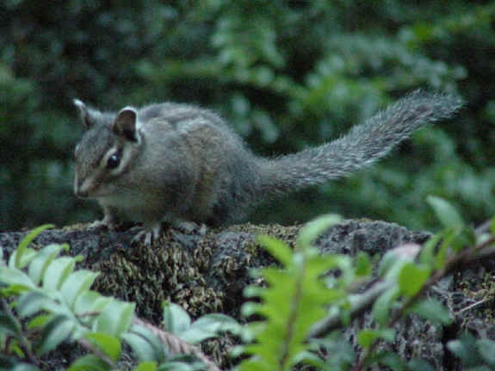
Chipmunk on a stump. Chipmunks are very active and hardly ever sit still long enough for a photograph.
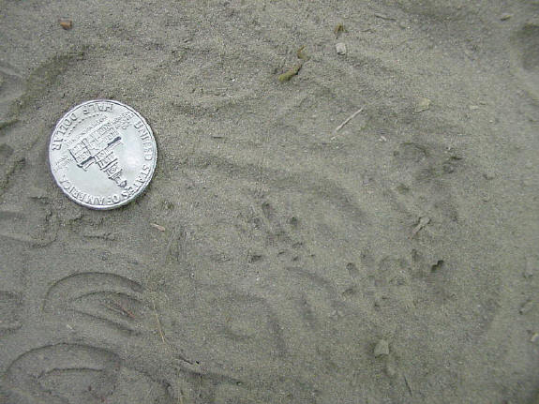
Chipmunk tracks with a half dollar for size comparison. These were found on a trail with fine river silt. The other tracks in the photo are human tracks.
Copyright © Kim A. Cabrera 2004

