Coyote
Canis latrans
Range: Throughout the U.S.  Habitat: Forest, desert, mountains, prairies  Size: 30-45 pounds  Young: 3-9 pups born in April or May  Tracks: Front 2½-3 inches long, hind 2-3 inches long  Scat: Varies according to diet  Stride: 16-20 inches  Diet: Small mammals, eggs, fruit, berries, nuts, rodents, fish, carrion, insects, grains, vegetation, and even human garbage. | Narrative  Coyotes are very intelligent animals that have been able to adapt to many different environments. Some live in major cities such as Los Angeles, feeding off human garbage and hunting mice and rats. In fact, the city of Los Angeles is home to about 3000 coyotes who roam the streets at night. They have adapted so well to the urban environment, that few people even know the coyotes are there.  Their tracks average 2½ inches long. The hind print is smaller than the front one. The inner two toes are smaller than the outer two. Coyotes have great stamina. They are good runners and swimmers.  They can eat a wide variety of foods, such as small mammals, eggs, fruit, berries, nuts, rodents, fish, carrion, insects, grains, vegetation, and even human garbage.  Dens are usually located in hollow trees, stumps, rock piles, or in brush. A coyote digs its own den, but will sometimes enlarge the burrow of another animal.  Young coyotes, usually three to nine pups per litter, are born in a den or shallow burrow in April or May. After they are about ten weeks old, the pups begin hunting together. By fall, they can survive on their own. Coyotes hunt both night and day. They have been known to cooperate and run down their prey in relays.  The coyote has a wonderful voice. I remember many nights when I sat up late listening to the coyotes howling at each other. It is a spine-tingling sound.

Coyote Tracks and Sign
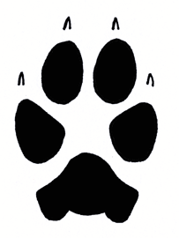  2.5 in. L x 2.25 in. W | 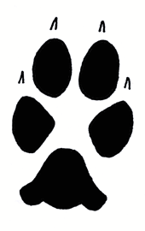  2.25 in. L x 2 in. W
Coyote front track  Front tracks are larger than hind tracks. Toes are not as splayed as those of domestic dogs. | Coyote hind track  Hind track is narrower than front track. Heel pad often shows up as just a round dot.
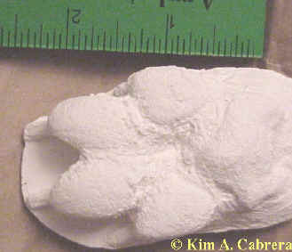 | 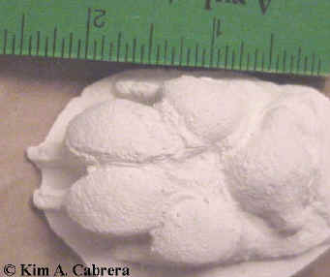
Plaster cast of coyote front track | Plaster cast of coyote hind track
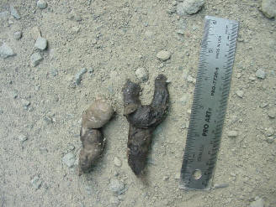 | 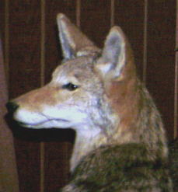
Coyote scat on a dirt road  This scat was located in the middle of the road. | Coyote  Specimen in a nature museum
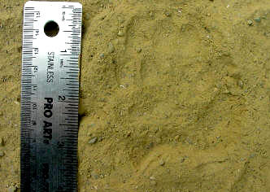 | 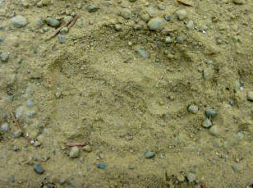
Double coyote tracks  The fine dust shows the details of these tracks well. Claws did not leave imprints here. | Coyote tracks  Another pair with hind on top of front tracks.
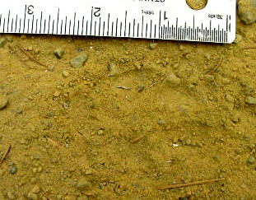 | 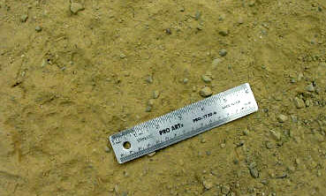
Coyote track  This single track shows no claw marks. The scat above was associated with these tracks. | Set of coyote tracks  The ruler scale here is six inches. Two pairs of tracks are visible. Direction of travel was from lower left to upper right of the photo.
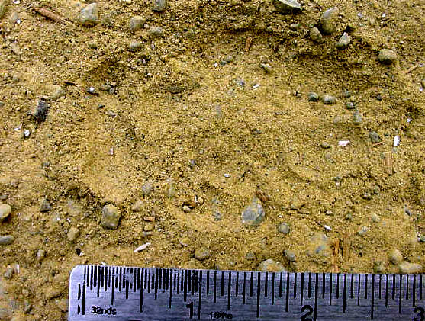
Coyote tracks
This is a pair of tracks. The hind track is on top of the front one. The heel pad of the hind track is barely visible in this photo. The hind track did not completely obliterate the front one. Claws did not leave an imprint.
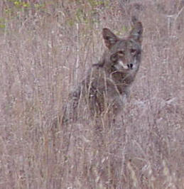 | 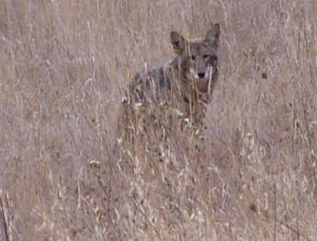
Coyote in grassy meadow. This particular coyote stayed near this location for several weeks. It may have had a den and pups nearby. People did not disturb it.
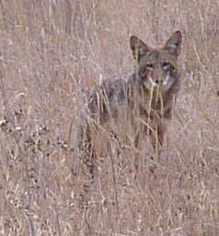 | 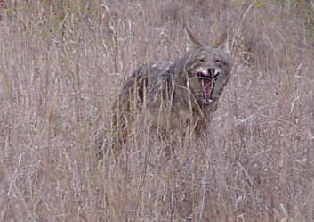
Coyote looking at the photographer | Coyote yawning widely!
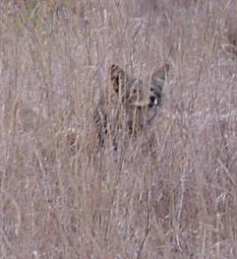 | 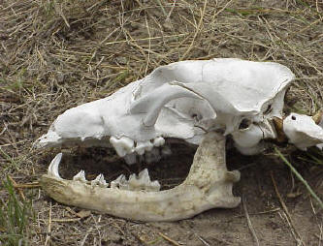
Coyote sitting down in grass and scratching. | Coyote skull

Gray Fox
Urocyon cinereoargenteus
Range: Eastern U.S., west coast, absent in prairies, deserts, high elevations  Habitat: Forest, brushy areas, swamps  Size: 7 - 13 pounds  Young: 1 to 7 born in spring  Tracks: Four toes on both front and hind feet  Scat: Often comes to a tapered point at the end, sometimes contains remains of prey (fur etc.)  Stride: 10 - 12 inches  Diet: Small mammals, birds, insects, fruit, nuts, grains | Narrative  Gray fox tracks show four toes and claws. Sometimes, the semi-retractable claws do not show. Their tracks average less than two inches in length. Tracks commonly run in straight lines, one print in front of the other. Front and hind prints overlap each other and appear as one print. Only foxes and members of the cat family walk in this manner. In fine mud, the hair on the foot may be visible in the track.  Gray foxes are primarily nocturnal and hunt small mammals. Sometimes, they hunt by day. They are the only canines that can climb trees. They seek refuge in trees and also climb to find food. The bark of the gray fox sounds like a hoarse cough. If you startle a fox, it may bark at you.  Foxes are omnivorous. They eat small mammals, birds, insects, eggs, fruit, nuts, grains, and even human garbage. Rabbits are a preferred prey animal. In campgrounds, you might see them at night, picking through fire rings in search of morsels from campers' meals. They are frequently seen crossing roads at night. In towns, they often eat pet food. In winter, when fewer plant foods are available, the gray fox's diet consists more of meat.  Foxes den in rock piles or hollow logs. They will stay in their dens during inclement winter weather, but they don't hibernate. About five young are born in spring. Both parents care for the young and teach them how to hunt. Fox kits are weaned at around 3 months.

Gray Fox Tracks and Sign
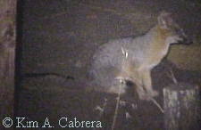 | 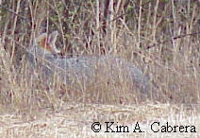 |  | 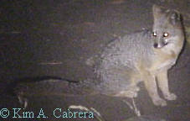
Gray foxes can be active day or night, although mostly at night. Some foxes become very bold when they live near humans and will approach during daylight.
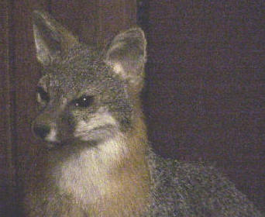 |  | 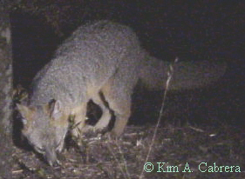
Gray fox museum specimen |  | Gray fox hunting at night.
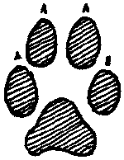  Front track  1 7/8 in. L x 1 3/4 in. W |  | 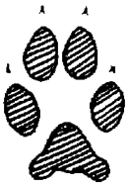  Hind track  1.75 in. L x 1.5 in. W
Gray fox tracks. The front (left) is larger than the hind. There is a lot of open space between the toes and the heel pad. This is characteristic of foxes. The claws may or may not leave marks. Claws are sharp like those of cats.
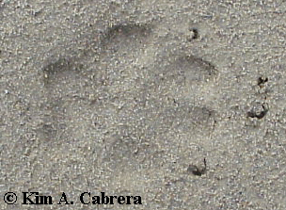 |  | 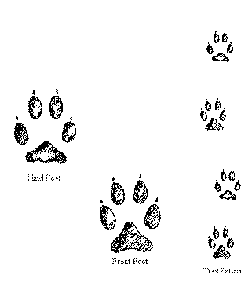
Perfect front track in sand |  | Gray fox tracks and trail pattern.
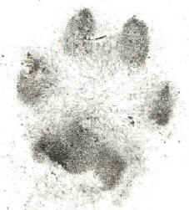 |  | 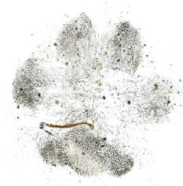
Gray fox tracks from baited soot plates. These are the actual "fingerprints" made by the fox itself as it walked through the soot, then onto clean paper. Notice the large amount of fur on the foot and the open space between the toes and the heel pad.
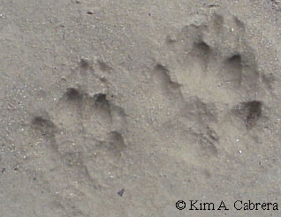 |  | 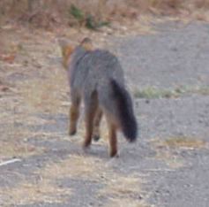
The hind track is shown on left. You can tell it is a hind track because the heel pad is smaller than that of the front track on the right. Front tracks are larger than the hind ones. Most of the weight of the body is carried by the front tracks. |  | Fox on a road during daylight. This fox was hanging around a camp, hoping to get some food.
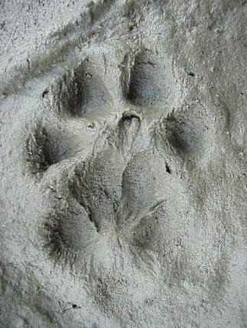 |  | 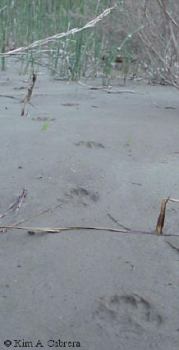
Pair of gray fox tracks. The larger front foot is underneath the hind foot. Hair marks are visible in the hind foot. |  | Gray fox view of its own trail. This photo was taken looking down a fox trail through sparse vegetation.
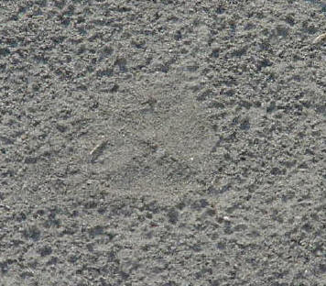 |  | 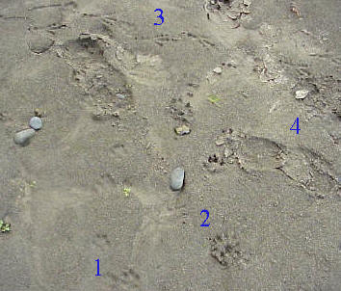
This fox track is hard to see. The flattened area in the center of the photo is the track. It had rained before the fox walked here. Its track does not show pock marks from rain, which helps the tracker age the track. |  | Trails of a gray fox (1), river otter (2), raven (3), and human (4).
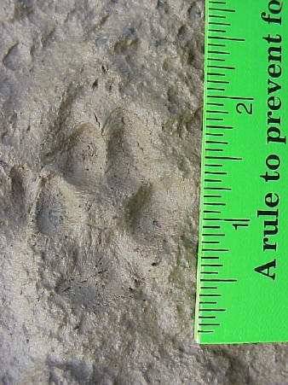 |  | 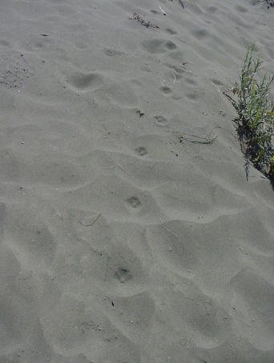
Pair of gray fox tracks with ruler for scale |  | Gray fox trail through soft sand. Notice how it travels in a straight line. Most wild canines don't waste energy by running all over like domestic dogs do when they get outdoors. Wild canines tend to move in relatively purposeful ways, although they do play sometimes. Behavior clues like this can help you identify various tracks.
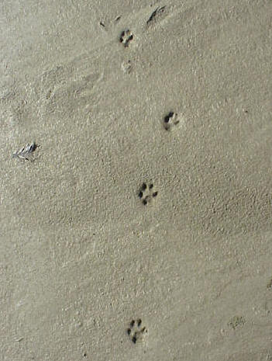 |  | 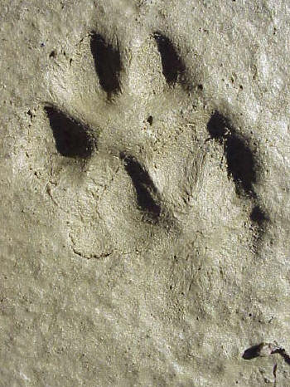
Clear set of gray fox tracks in mud |  | Close-up of pair of tracks showing details such as the fur on the feet. The claws did not register well in these tracks.
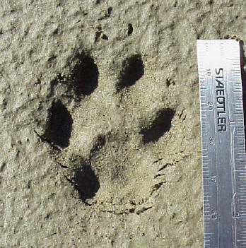 |  | 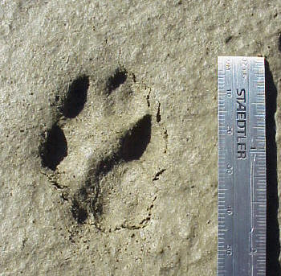
Perfect front track. Sharp claws left marks ahead of the track. |  | Perfect hind track. Notice the smaller heel pad with three parts. Most canine do have three parts to the hind edge of the heel pad, although some tracks show it better than others.
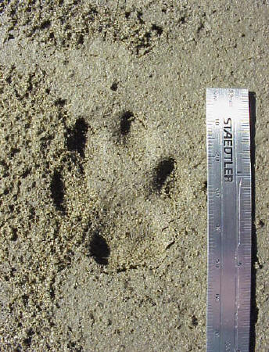 |  | 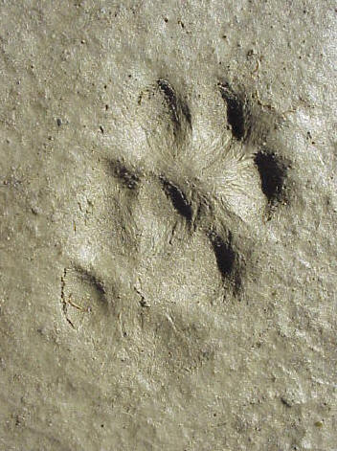
Gray fox front foot |  | Pair of overlapping tracks. When you find tracks like these, it is easy to see how they can create confusion. They do almost look like one track with 7 toes!
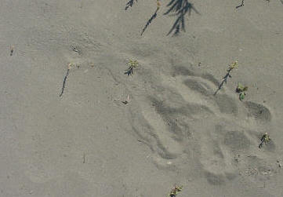 |  | 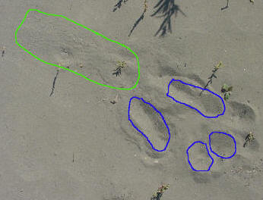
These tracks tells an interesting story. A gray fox came in from the upper left. It then sat down in the sand for a moment, possibly to scratch, then it walked off. It is interesting to find complete stories like this. That's part of the fun of tracking. |  | The track from the previous photo with the various features outlined. Having the photos side-by-side allows you to compare them. The green outline is the brush mark from the tail. The large blue outlines are the hind feet, which show the entire heel. The blue circles are the front feet, which were placed in front of the fox.
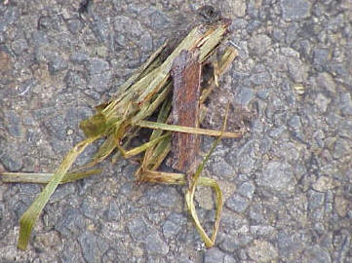 |  | 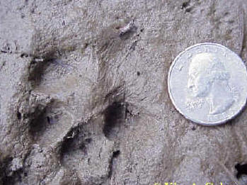
GRass that was eaten and passed through the digestive system. Foxes and other canines will do this to clean themselves out. |  | Fox track with the tracks of its prey next to it. There are mouse tracks in the upper right, above the quarter.
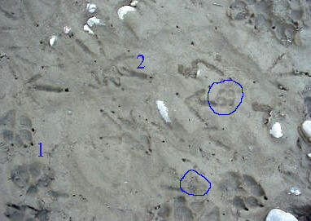 |  | 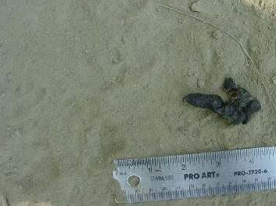
Tracks of a gray fox (circled), a dog (1) and turkey vulture (2). |  | Gray fox scat found with gray fox tracks in fine dusty silt.
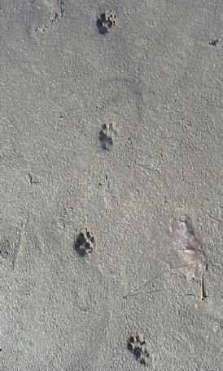 |  | Listen to a fox call
Gray fox trail in sand. Each track is actually a pair of prints. |  | Fox calls are not sharp barking sounds like those of domestic dogs. They are more hoarse.

Gray Wolf
Canis lupus
 | Tracks and sign  Range: Minnesota, North Dakota, Montana, Michigan, Alaska, Canada  Habitat: Forest, brush, meadows, riparian  Size: 110-130 pounds  Young: Born between April and June  Tracks: Four toes on both front and hind feet  Scat: Large, tapering on the ends  Stride: 62 inches when trotting  Diet: Small mammals, moose, deer, caribou, some plants | Narrative  The gray wolf used to range throughout the U. S. Due to its predatory nature, it was seen as a threat to cattle. Many wolves were exterminated as part of government extermination programs aimed at protecting livestock. However, wolves were blamed for a lot more than they actually were responsible for.  Wolves are now found in a few northern states, including parts of Minnesota, North Dakota, Montana, and the upper peninsula of Michigan. They live in Alaska and in most of Canada. The wolf is the largest wild canine in North America. Gray wolves can be gray, white, black or silvery. Some have facial markings that resemble those of huskies or malamutes. Gray wolves are also called timber wolves. They live in packs, although some animals will travel alone. Packs are nomadic and may range more than 250 miles. During the time when the alpha female has her pups in the den, the pack stays in one place. Other than that time, they are always on the move.  Their primary prey include deer, moose, and caribou, although they frequently eat small mammals. Rodents from a major part of their diet. They will also eat various kinds of plants to get needed vitamins and minerals. Wolves have good hearing and a well developed sense of smell. This helps them find prey in their forested environment. Wolves have sharp eyesight. A wolf can run at 30 mph. When wolf packs hunt, they often set up ambushes to catch prey. They cull out weak or sick animals as they don’t have the speed to run down a healthy deer. The pack will charge a group of deer and quickly determine which is the weakest one. That is the animal they will try to catch. If a deer turns and fights, the wolf pack may move on to easier prey. Injury from a deer’s sharp hooves can lead to the death of a wolf.  Wolf packs are territorial. If there is an abundance of prey, several packs may have overlapping territories. Each pack has a pair of leaders, known as the alpha pair. These are the only animals in the pack that breed. The pups are born between April and June. The average litter size is seven, but litters of up to 14 have been known. The entire pack helps feed and care for the pups. They bring food, which is then brought to the mother by the alpha male, the only other pack member who is allowed to approach the den. All pack members will take turns looking after the pups once they emerge from the den at about one month. Wolves are very social animals and have elaborate facial and body language displays that allow them to communicate to each other. The average life span of a wolf can be up to 18 years, but is more likely to be around 10 years.  Wolves don’t hibernate. When the weather is bad, they may curl up in a ball and let snow drift over them to provide extra insulation. They sleep in the open as they don’t have many predators to fear. One member of the pack will stay alert and act as a sentinel to warn the others of danger.  Wolf tracks, like those of all canids, show four toes on each foot with claw marks present. Wolf tracks are robust, often measuring 4¼ to 4¾ inches long. Wolf tracks can be difficult to distinguish from those of large dogs. The main difference is in habitat. Wolves are found farther from human habitation than dogs are. The stride of a wolf can be 26 to 30 inches. Wolves can run 30 to35 mph. At top running speed, the distance between groups of tracks can be six to eight feet.  Wolf scat will usually have the hair and bones of its prey. Scat can be 1½ to 2 inches in diameter. Some plant material may be present, such as grass or seeds.  Wolves will mark their territory with scent markings. Scent posts on prominent landmarks tell other canids who is around. Wolves, as do most canids, use urine to mark the prominent landmarks. They also leave droppings in the middle of trails to advertise their presence. Canids will scrape near the scent deposit to spread the scent around and let other canids know whose territory they're in.  Wolves and other animals, including bears and cougars, will cover partially eaten meat with dirt. You should never approach one of these camouflaged carcasses because the animal may not be far away. Bears and cougars will defend these partially eaten carcasses. Wolf packs may or may not, but it’s best not to take the chance.  Wolves have a complex vocal communication system. They use yelps, whines, growls and body language to communicate amongst themselves. Posture is used to indicate the wolf’s position in the pack. Submission to a dominant pack member is indicated by a cowering stance and whining. The submissive wolf will lick the dominant wolf’s face. A wolf will growl, snarl, lay back its ears, and raise the hair on its back to let another wolf know to back off. Wolf howling serves as a communication between the entire pack. Wolves tend to give long howls instead of the yapping calls that coyotes are known for. When hunting, the pack will scatter out and use howls to keep in contact with each other. If a wolf finds prey or food, it will call the others with a special howl.
Gray Wolf Tracks
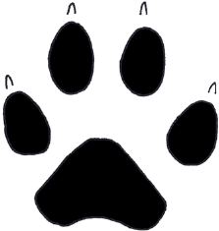  Front track  4.25 in. L x 4 in. W |  |  | 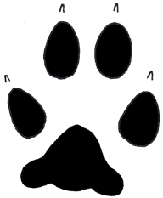  Hind track  3.75 in. L x 3.25 in. W
Gray wolf tracks. Although differentiating the tracks of canines can be difficult, take into account the habitat and other clues to help you identify a set of tracks.

Domestic Dog
Canis familiaris
Range: Throughout U.S.  Habitat: Found in all habitats  Size: Six to 39 inches tall at shoulder, depending on breed  Young: Two to ten or more depending on breed  Tracks: Four toes on front foot and four on hind foot, shows claws  Scat: Tapered or pointed on the ends, size will vary depending on breed  Stride: Varies between breeds  Diet: In the wild, dogs are omnivorous. Domestic dogs are usually fed a variety of commercial foods. | Narrative  Domestic dogs are related to wolves, foxes, and coyotes. Dogs have been around people for many thousands of years and there are too many different breeds to dogs to list here. Domestic dogs are related to wolves, and may have been the first animal domesticated by humans.  Like most canines, dogs are characterized by having long muzzles, long tails, and big canine teeth. Dogs vary so much in size that there is no way to generalize about such characteristics as height and weight. For example, a chihuahua can stand about six inches tall at the shoulder while an Irish wolfhound can stand over 3 feet tall at the shoulder!  Dogs have worked for and with humans for many years. Their sensitive noses have been put to work finding lost people in the wilderness, as well as sniffing for bombs and drugs. Their fine senses of hearing and sight, as well as intelligence and friendly disposition have made them excellent guide dogs.  A female dog can mate when she comes into heat, which happens about every six months. Litter size varies among breeds, but can be anywhere from two to ten or more.  Dog tracks show four toes on both the front and hind feet. The claw marks usually register in tracks. Dogs also have a fifth toe, located further up the front leg, that does not leave an imprint in the tracks. The hind leg does not have this extra toe.

Dog Tracks and Sign
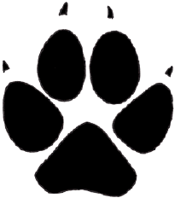 | 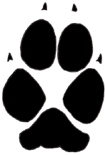
Domestic dog tracks. Size of tracks varies depending on breed of dog.
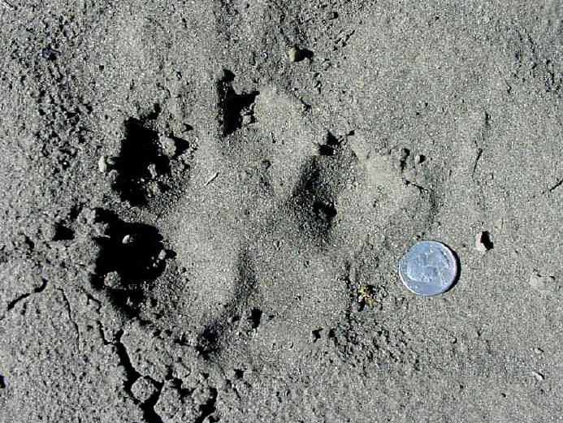
A large domestic dog track in loose sand. The dry, loose sand contributed to the large appearance because it collapsed into the track as soon as the foot was lifted. It was still a fairly good-sized dog track.
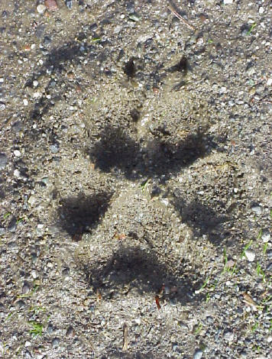 | 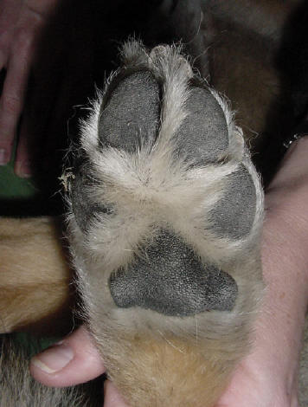
Dog track in mud. Breed was Golden Retriever. | The foot structure of a domestic dog. Note four toes and the triangular shape of the heel pad.
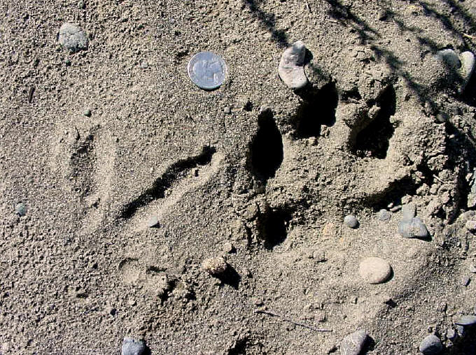
Large dog track with wild turkey track to the left.
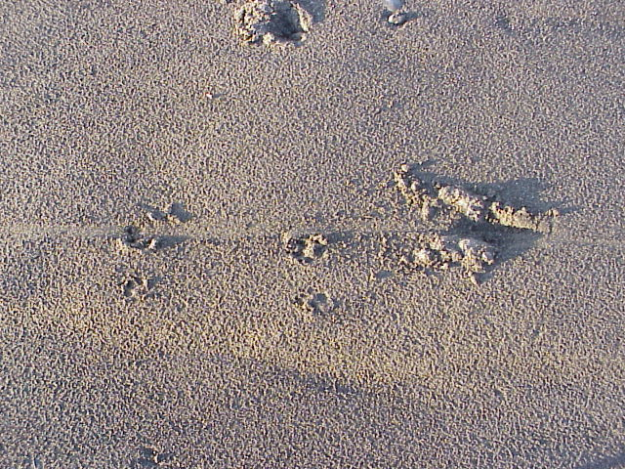
Interesting dog trail found at the beach. This small dog was dragging its leash behind it, making the long, straight mark in the sand.
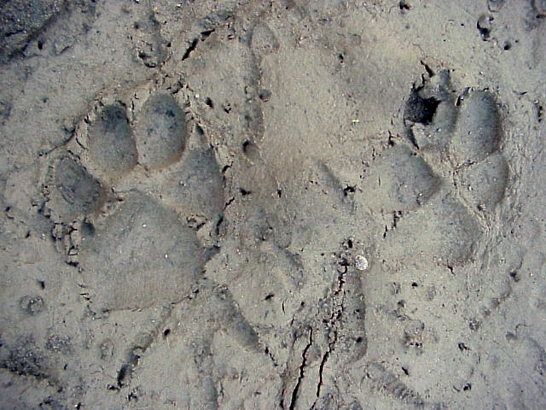
Pair of domestic dog tracks. Larger front track is on the left. Narrower and smaller hind track on the right. One interesting thing to note here is that the claws did not register.
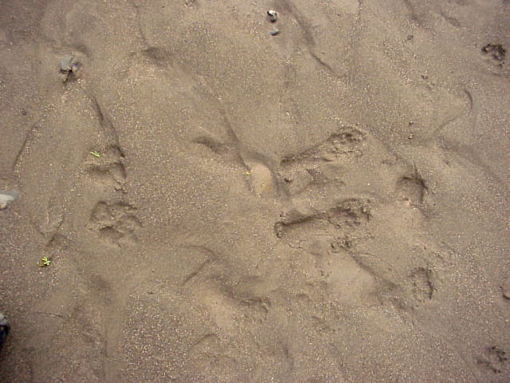
Interesting dog tracks. This dog walked in from the left, sat down and scratched its side, then got up and walked off to the right. The large tracks in the center are the heel prints.
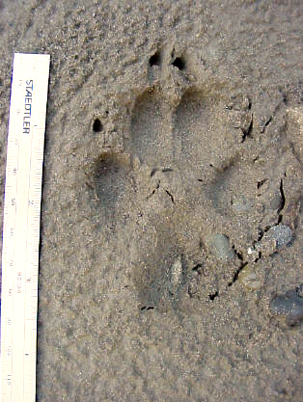 | 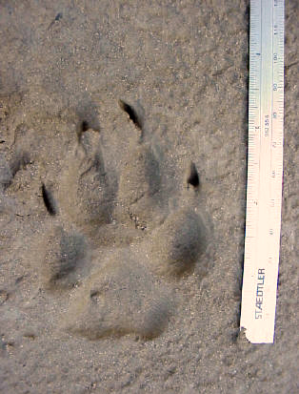
Dog track - hind foot. Hind tracks are narrower than front. Claws generally show in dog prints. | Dog track - front foot. The heel pad of the front pad is bigger than the hind.
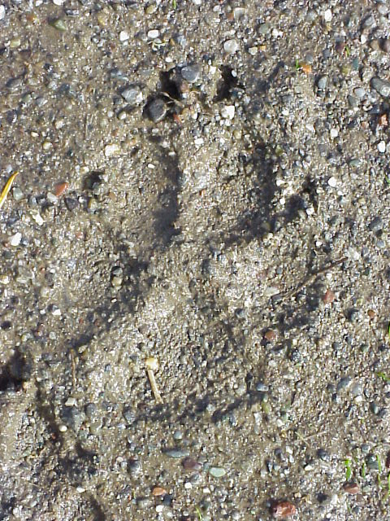
Domestic dog track in mud. Outer toe pads are somewhat triangular in shape. The intersection of the four toes and the heel pad forms an "X" in the middle of the tracks, which is diagnostic of canine tracks.
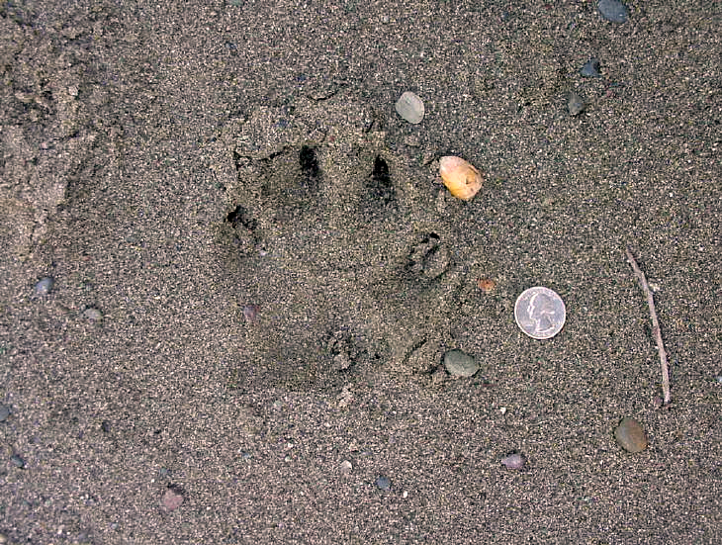
Dog track showing the feature that most prominently identifies it - the claw marks. Cats generally retract their claws, so they don't leave marks in the tracks.
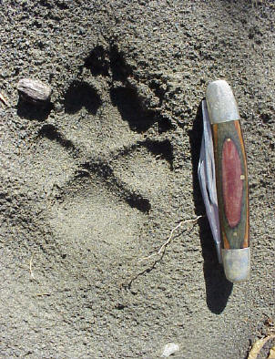 | 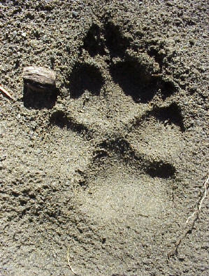
Track of a Golden Retriever in damp sand.

Domestic Cat
Felis domesticus
Tracks and sign  Range: Throughout the U.S.  Habitat: Domestic  Size: Up to 15 pounds  Young: Litter of 1-8 young born between January and March  Tracks: Four toes on front and hind feet. Fifth toe does not often register in front tracks  Scat: Sometimes segmented, sometimes blunt ends  Stride: 6-12 inches  Diet: small mammals and birds, cat food | Narrative  Cat tracks show four toes on the front foot and four toes on the hind foot. Cats do not show their claws in their tracks because they are retractable. Cats, unlike dogs, keep their claws sharp by not walking on them. The two front toes in a cat track are not aligned right next to each other. The inner toe is set further out than the outer toe of the pair.  When we think of cats, we usually think of pets. However, there are many feral domestic cats running around. They can live singly or in colonies of cats.  Cats are usually nocturnal, or active at night. They will get up early in the morning and have a "play time." (My cats always do this when I'm trying to sleep.) Afternoon is nap time. Play can consist of pouncing on toys, on other cats, on leaves, or any other moving object. Some cat play is actually practice for hunting.  Female cats are good hunters. This is because they feed the young. Cats are ambush predators. They don't chase down their prey in long chases. They tend to lie in wait or stalk their prey and pounce on it. They eat small mammals, birds, and anything else they can catch. Prey is killed with a bite to the back of the neck. Female cats will bring live prey back to young to teach them how to catch it.  Cats have sheathed claws (retractable). Keeping the claws sheathed until they need them helps keep them sharp. Dogs walk on their claws all the time and the claws get dull as the dog ages. However, a wild canine's hunting strategy is different. They chase down their prey over long distances. Cats rely on stealth and ambush in catching prey. Their claws must be sharp and ready when they need them.  Cats are territorial and have a variety of methods for marking their territory. They will spray urine on objects, scratch trees and posts, rub their faces on things, and leave scat, or droppings, as a marker to let other cats know whose territory they are in. Male cats do more spraying than females do, although females do sometimes spray. If a cat feels threatened by the presence of a new cat, it may go out and re-mark its territory. Scratching trees and upright objects is a way for a cat to display its size to other cats. The higher the scratches, the bigger the cat. When a cat rubs on something, scent glands on the side of the face leave behind odors for other cats to find. House cats do this a lot, even rubbing their faces on their owners to mark them. Cats will also butt heads in displays of affection for one another. Domestic cats bury their scat, but wild cats will sometimes leave it exposed as a way of claiming territory. Cat scat is in segments and is somewhat blunt on the ends.  Cats can breed any time of the year, and a single pair of cats can produce two or more litters a year. The mother cat will keep the kittens hidden until they are about five or six weeks old.  So, why does my cat have five toes?  Domestic cats have a fifth toe, with a claw, located higher up the "wrist," which does not usually leave an imprint in the tracks. This claw is called the "killer claw" and is sometimes used in hunting. There is also a sixth pad located even higher up the "wrist" that lacks a claw. Very rarely will you find either of these imprints in the tracks. If you do find them, it is usually because the animal is running. Take a look at the photo below of the cat foot on the tracks page and you will see both of these structures. (Check the Bobcat page to see a photo of a bobcat track showing these features.) I don't know what function the sixth toe has, other than just being there. The fifth is used to help grip prey. Since cats lack an opposable thumb, it could possibly serve a similar purpose to them. If you do find these imprints in a track, look for other clues as to what the animal was doing. Sometimes you will find them where cats have been playing in damp sand, or running in mud.  There is also another phenomenon which could account for a cat track showing more than four toes. This is called polydactylism. Occasionally, a cat is born with five or six toes on all its feet, plus the "killer claw" and extra pad on the "wrist." This growth of extra toes happens frequently in populations of feral cats, and is also something that cats are bred for. Apparently, it doesn't affect their ability to survive. I once owned a six-toed cat. I now wish I had taken photos of its tracks!

Domestic Cat Tracks and Sign
Left front track | Right front track
Left hind track | Right hind track
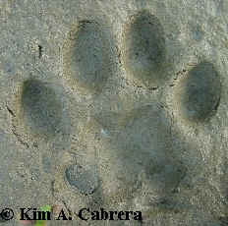 | 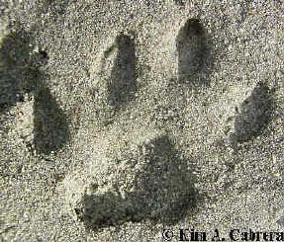
Perfect left front track  A single claw mark show up above the toe in the left. Cat claws are retractable and do not often show up in their tracks. | Perfect left front track - toes splayed  The leading toe will tell you which track this is. This is the left front track.
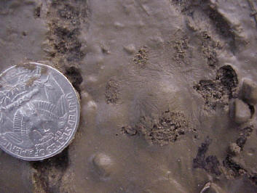 | 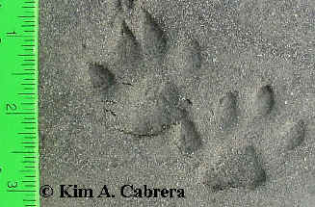
Cat track in mud, showing fur  Fine mud like this is great for finding details on tracks. It is also a great place to look for the tracks of the lighter animals, such as mice, who don't leave much imprint in harder soil surfaces. | Pair of perfect cat tracks  Perfect tracks are hard to find. This pair was in damp sand along a river.
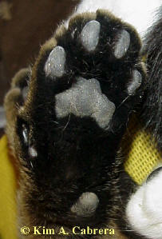 | 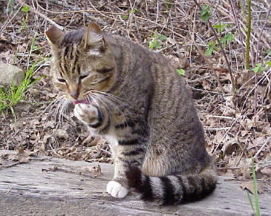
Cat left front foot (from a sleeping cat)  The fifth toe is just visible on the left side of the wrist. One the right side of the wrist, is a sixth toe pad, which is rarely visible in tracks. | Chris, the cat  Cats groom themselves using their tongues.
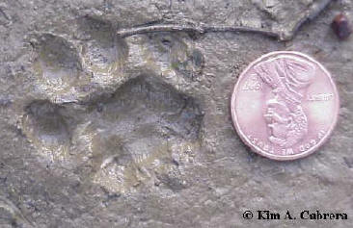 | 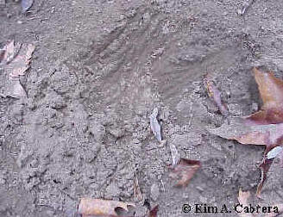
Domestic cat right front track  Deep mud shows all the details, including the lack of claw marks, and the three parts to the hind edge of the heel pad. | Scratching by a domestic cat  Cats often scratch to cover their scat.
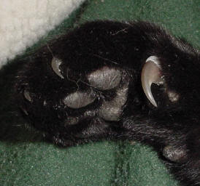
The "killer claw"
The fifth toe, with claw, is located higher up the cat's wrist, and does not always leave an imprint in the tracks. The "killer claw" is used to grasp prey. Cats hunt their prey by stalking and pouncing from ambush. They don't need to use their claws to chase down their prey as dogs do. They keep them retracted until they need them. (Photo from a sleeping cat.)
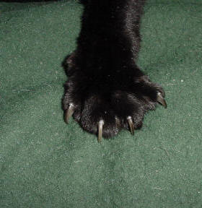 | 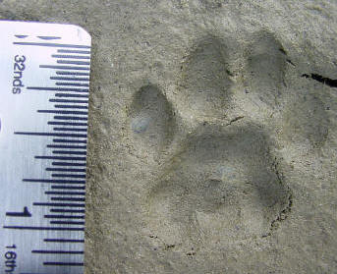
Cats keep their claws sharp by digging them into objects, such as trees, posts, even furniture. This helps to remove the old claw sheaths, exposing the new sharp ones underneath. | This track shows all the details of a perfect cat track. Perfect tracks are rare. There are no claw marks, there is a "leading toe," the heel pad has three lobes on the hind edge and two on the leading edge.
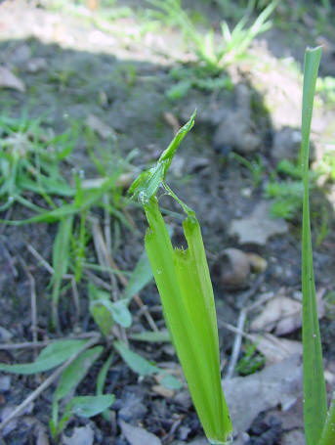 | 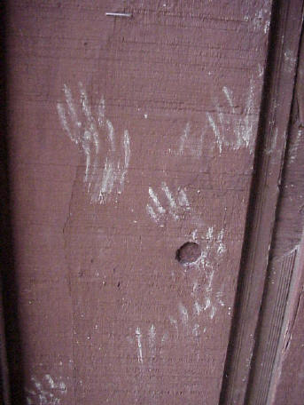
Chewed grass. Cats will chew grass to aid their digestion. | These muddy paw prints on a fence were the work of a cat who climbed it repeatedly. Tracks are not found just on the ground.
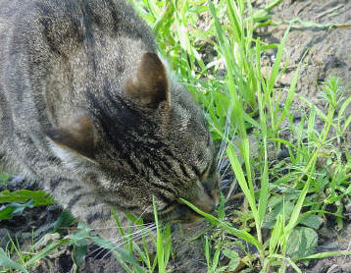 | 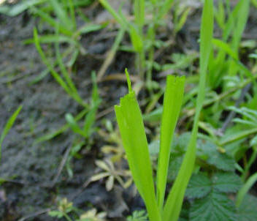
This cat is in the process of gnawing on some grass. | The rough cuts on the grass tips indicate this sign was the work of a cat.
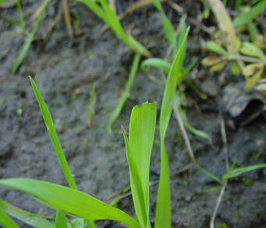 | 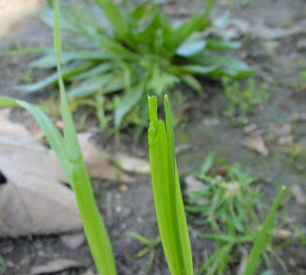
The cuts on these blades of grass are more neat than others pictured here, but they were made by a cat. | When deer eat grass, they grab the blades and pull upward to tear them off. These blades of grass show a mangled appearance that comes from being gnawed on.
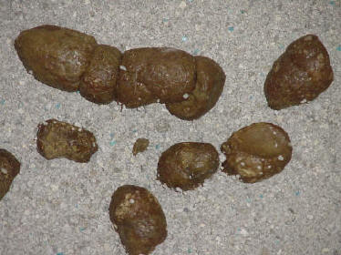 | 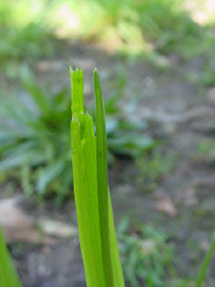
Domestic cat scat. The appearance is somewhat segmented. It sometimes falls apart easily. | This mangled grass blade was the result of cat gnawing.
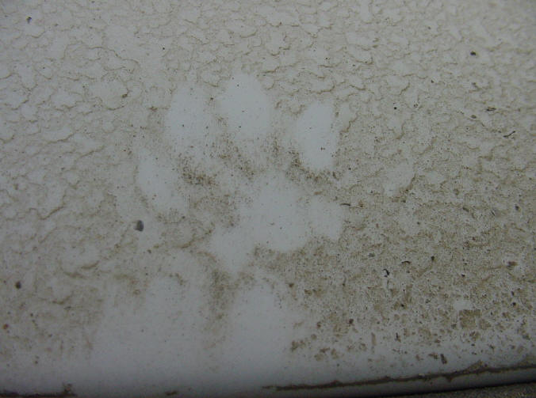
Domestic cat track in the dust on a car. This is a commonly found sign.
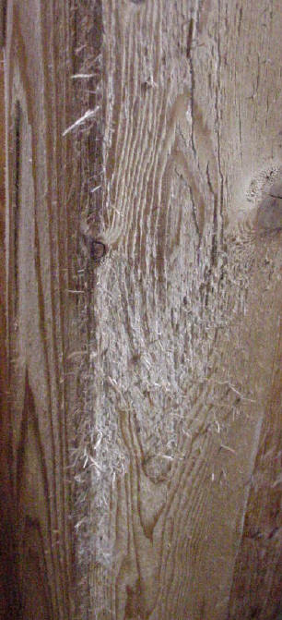
Domestic cat scratching on a wooden post. This is done to sharpen the claws and remove old claw sheaths. It is also probably territorial.

