Listed below are David’s pets. Make a table that shows David’s pets.
Start by inserting a table with 6 columns and 8 rows.
4 dogs 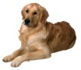 5 fish 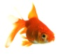
3 cats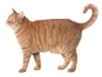 1 rabbit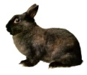
2 frogs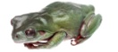 2 mice

