If your child is assigned Eureka (also called Engage NY) math homework, the following link can offer support for each homework assignment.
http://eurekamathhelp.piqua.org/student-math-resources
(This link can also be found on the Millridge website under “Links” on the right hand side of the page.)

This website offers many great resources. The two most beneficial for homework help are:
Homework Help Resources and Printable Parent books by module.
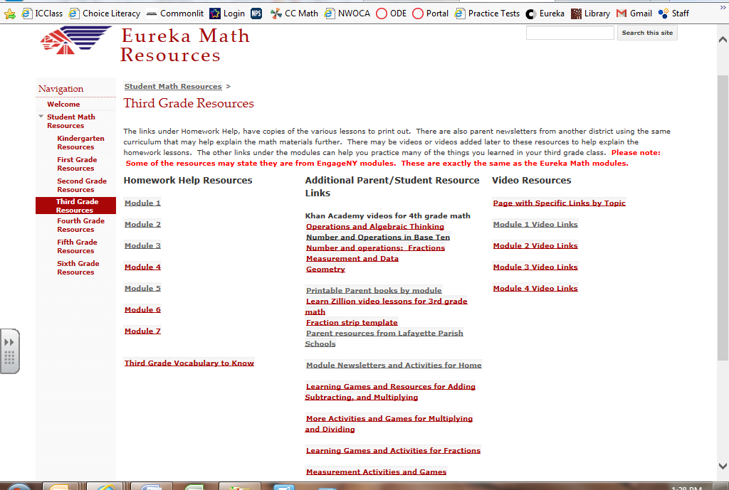
In Homework Help Resources, you can click on the module your child is currently in and follow the links to see an answer key and a video answer key of each assignment. Not every problem will be solved in the video, but hopefully there is enough support to help you and your child understand the approach presented in class.

Click on the yellow lesson titles to see the answer keys.

You can tell if an assignment is a Eureka assignment by looking in the top right corner of the HW. If it is Eureka it will look similar to this ->

Once you know the module and lesson your child is working on, you will be able to click through the links to find the correct video.
The Printable Parent books by module can also be helpful because they list the lesson objective and sample problems from the in class work that was done.

