Math 3 Name_______________________________

2-4 Exact Value Practice 2 (Radian)

**Answer the following questions WITHOUT using your calculator or your notes.**

1.  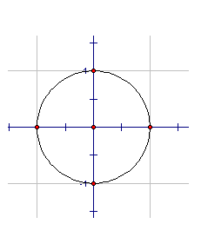 6. 

2.  7. 

3.  8. 

4.  9. 

5. 

**OVER 🡪**

**Answer the following questions WITHOUT using your calculator or your notes.**

**Find **

10.   11. 

12.  13. 