AP Calculus AB Name _________________________________

Extra Practice – Trapezoidal Method, Antiderivatives Date ________________________________

Show your work for the following:

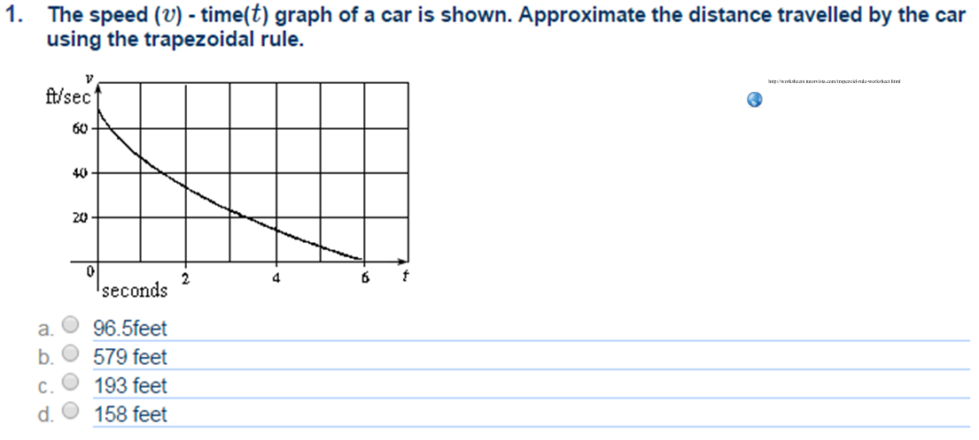



Underestimate or overestimate? Why?

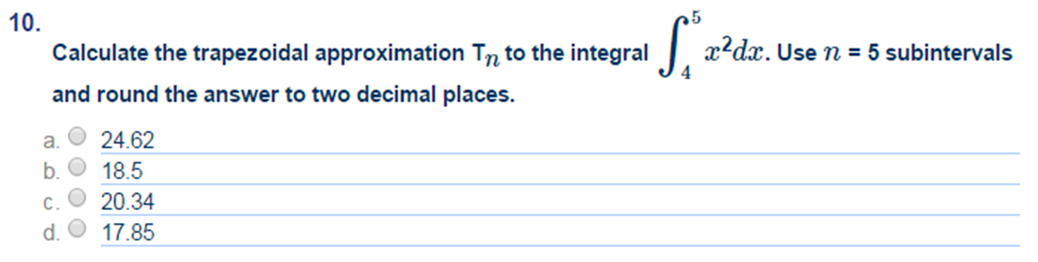

2.



Underestimate or overestimate? Why?

Use your calculator to find the exact value.

OVER 🡪

Evaluate each indefinite integral. (Don’t forget the “*C*”.)



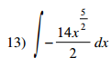 

 

Review:

***NO CALCULATOR***

Solve for *x.*

1.  2. 

3. Find : sin (2*x*2*y*3) = 3*x*3 + 1