Formative Assessment: section 8.1
Name ___________________________________ Date _____________
1. The most important source of short-term energy used to fuel cell work is:
a. Fat b. Sugar c. ATP d. DNA e. protein

2. Color in the choices for all of these examples that are examples of cell work.
a. active transport of substances across the cell membrane
b. cell movement
c. cell reproduction
d. synthesis of large chemical compounds like DNA or protein
e. production of body heat or light in the case of fireflies

3. Which is NOT an important molecule for long-term energy storage in organisms?
a. Fat b. Sugar c. ATP d. DNA e. protein

4. For a biologist, ATP is the abbreviation for:
a. Adenosine tri-phosphate b. Activity targeted protein
c. Adenosine di-phosphate c. Association of Tennis Players

5. Which contains the most energy?
a. one molecule of ADP b. one molecule of ATP c. one molecule of glucose sugar

4. Which of the following compounds contains two phosphate groups?
a. ADP b. ATP c. AMP d. APP

5-8. Which correctly fills each box in the ATP cycle diagram below?
a. ADP + P
b. ATP
c. cell respiration stores energy into ATP
d. energy is released from ATP to allow cell work
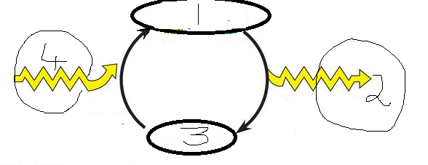
5. box 1 6. Box 2 7. Box 3 8. Box 4

9. True or False. ____ ATP is so unstable that cells only store a few seconds supply.

10. True or False. ___ Cell respiration allows cells to constantly replenish ATP using energy released from breaking bonds in food molecules like glucose. Each molecule of glucose stores enough energy to allow the cell to make 90 molecules of ATP!

11. Which chemical reaction shows the process used by cells to release energy from ATP? (to fuel cell work)
a. ADP + P + energy ATP b. ATP ADP + P + energy

12. Which chemical reaction shows the process used by cells to store energy in ATP? (during cell respiration)
a. ADP + P + energy ATP b. ATP ADP + P + energy

13. ____ is like a partially charged battery, while ___ is like a fully charged battery.
a. ATP, ADP b. ADP, ATP

